**1. Reverse a String 07-01-2025**

Write a function void reverseString(char *str) that takes a pointer to a string and reverses the string in place.

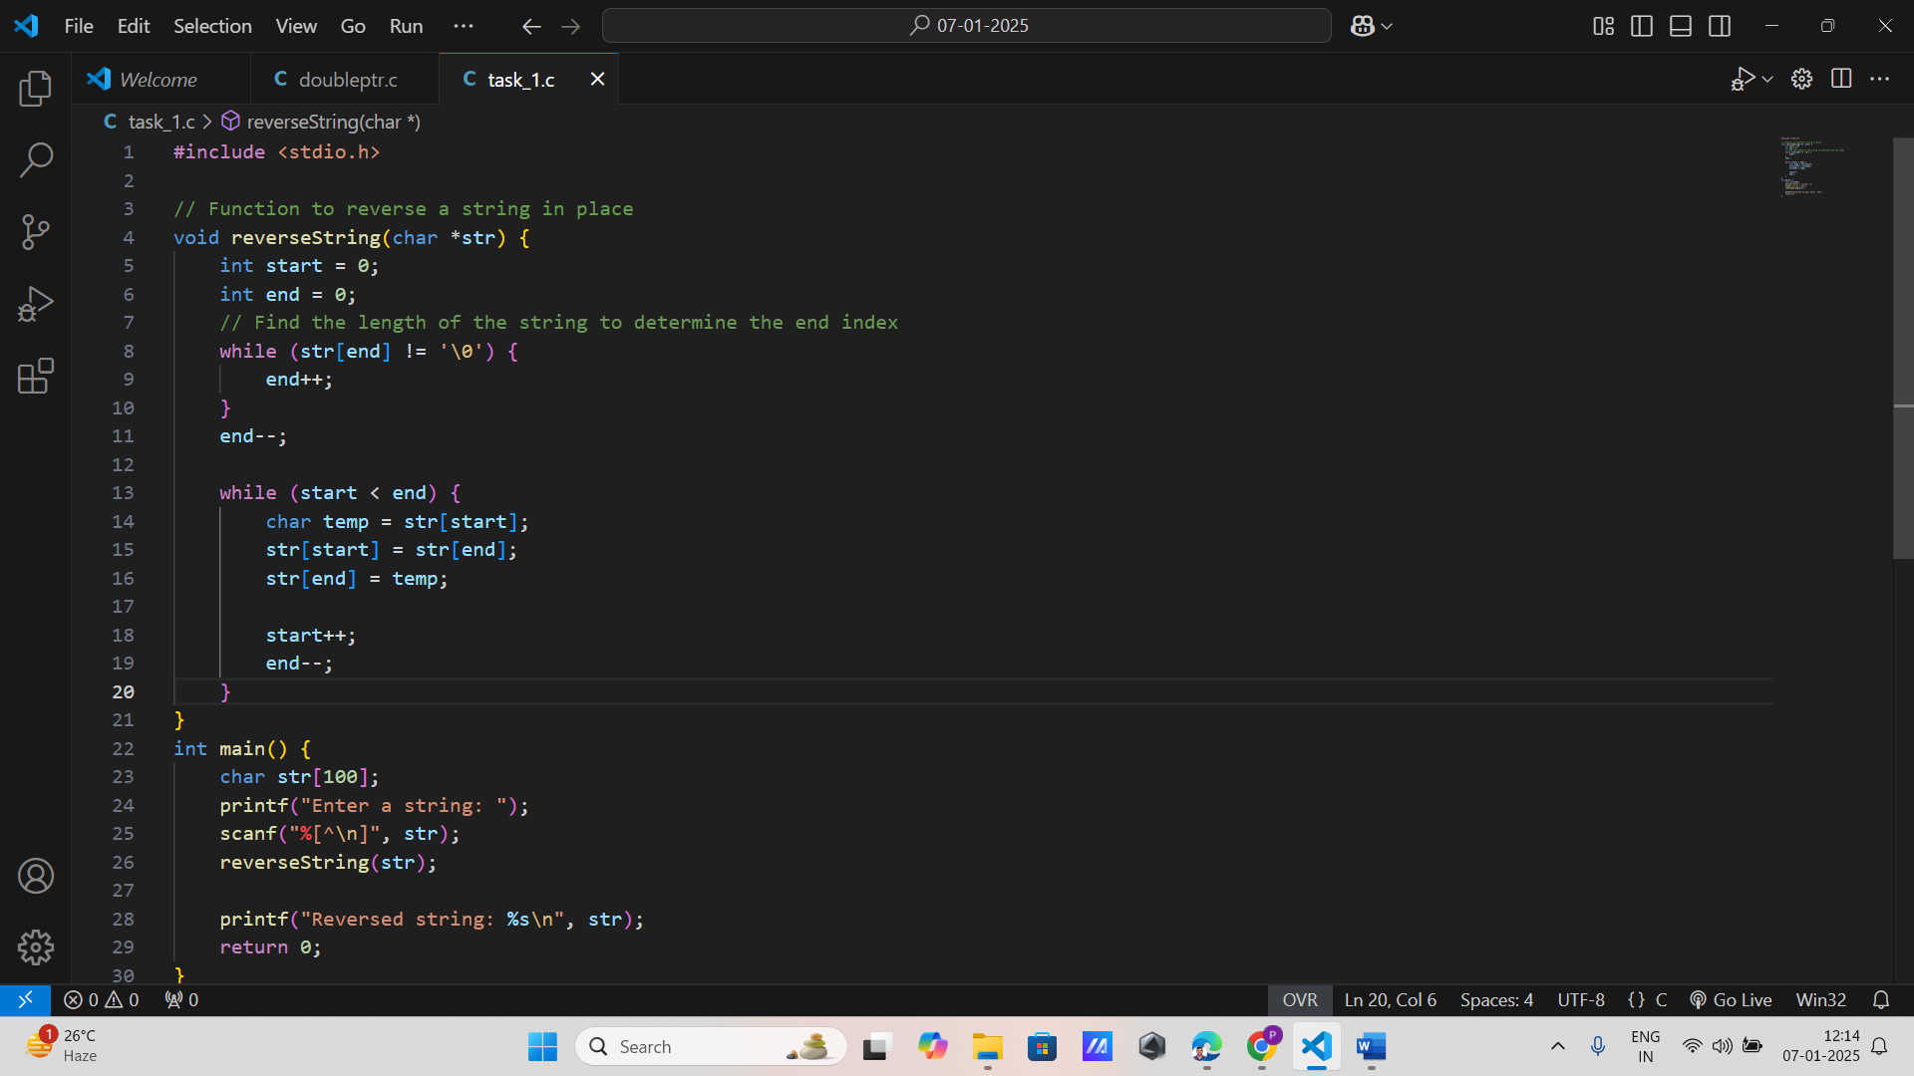

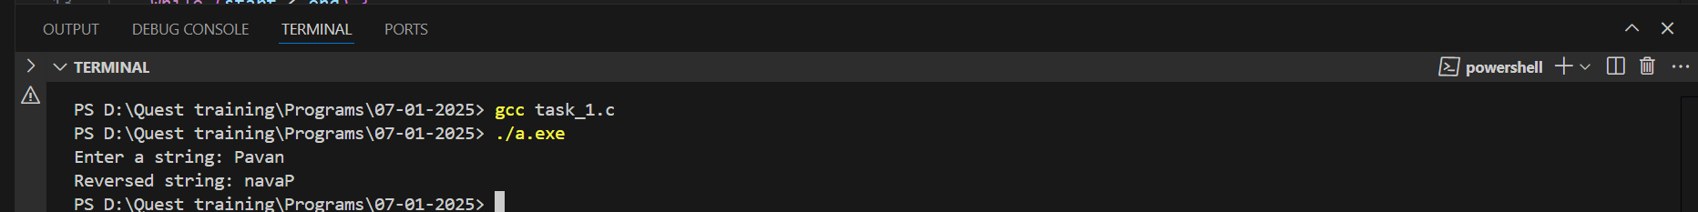

**2. Concatenate Two Strings**

Implement a function void concatenateStrings(char *dest, const char *src) that appends the source string to the destination string using pointers.

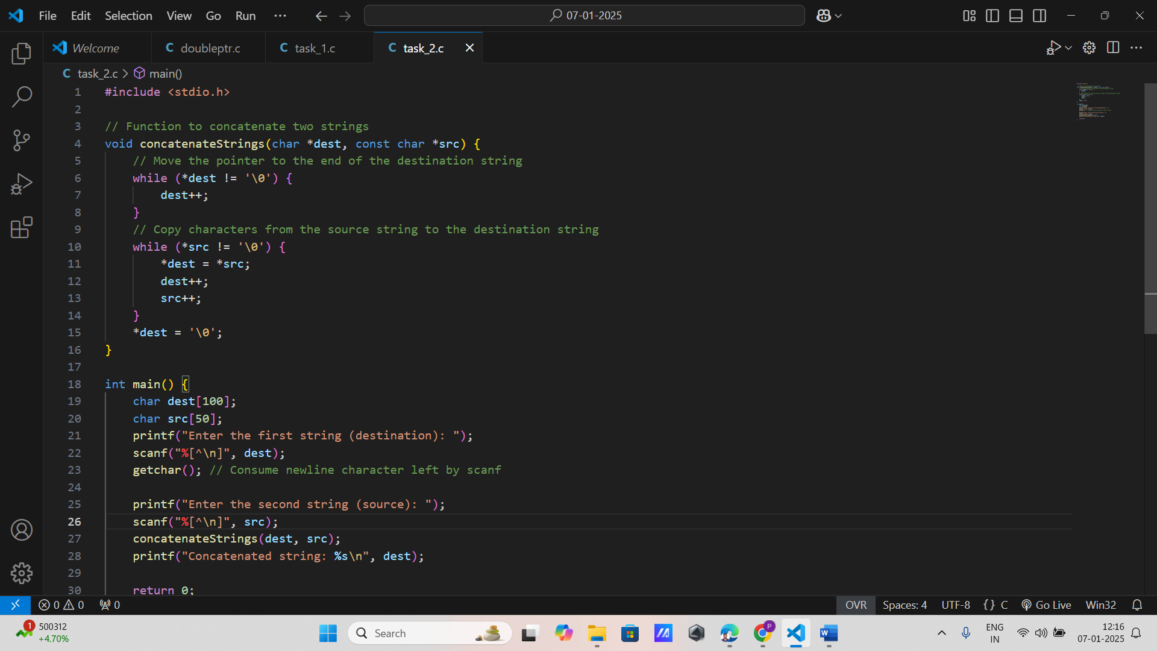

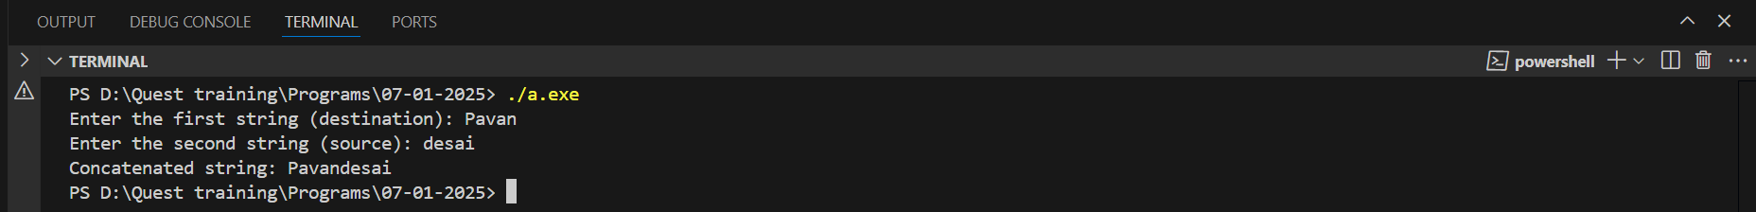

**3. String Length**

Create a function int stringLength(const char *str) that calculates and returns the length of a string using pointers.

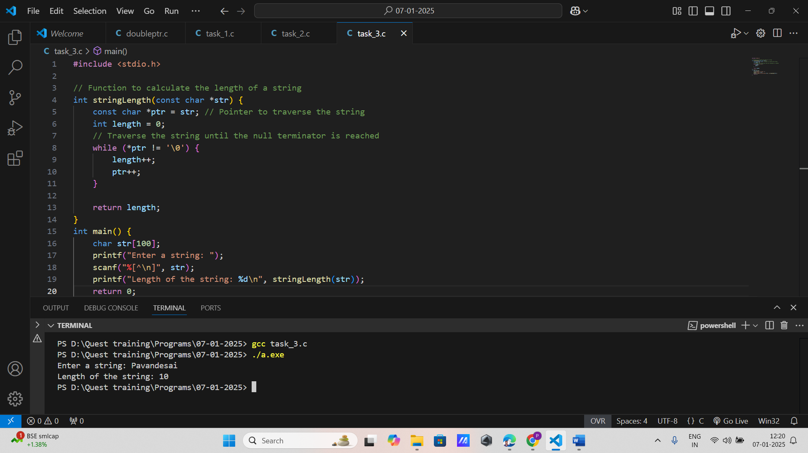

**4. Compare Two Strings**

Write a function int compareStrings(const char *str1, const char *str2) that compares two strings lexicographically and returns 0 if they are equal, a positive number if str1 is greater, or a negative number if str2 is greater.

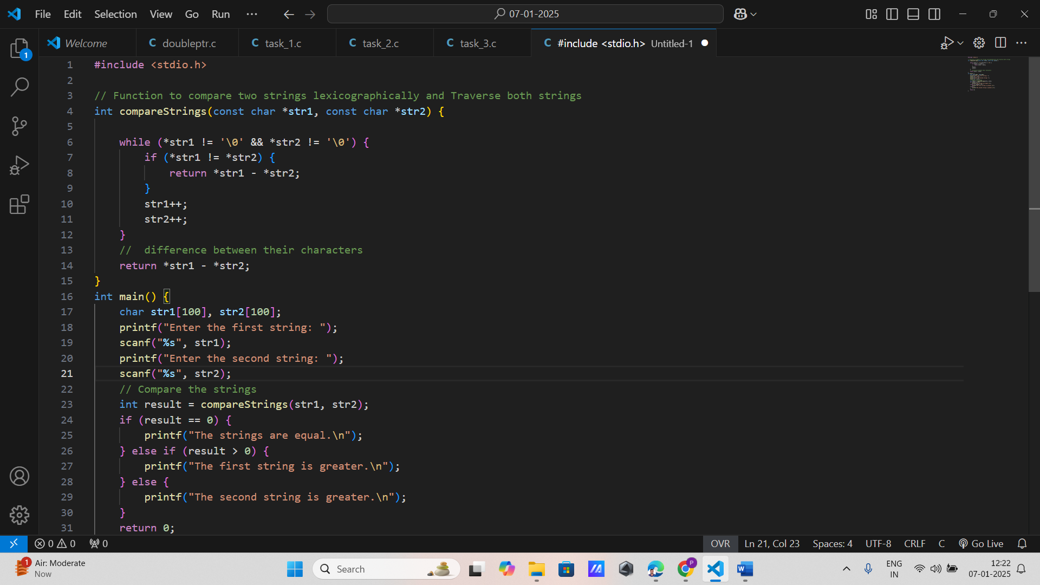

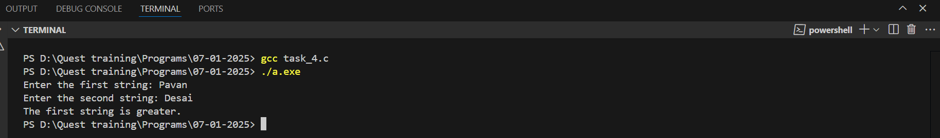

**5. Find Substring**

Implement char* findSubstring(const char *str, const char *sub) that returns a pointer to the first occurrence of the substring sub in the string str, or NULL if the substring is not found.

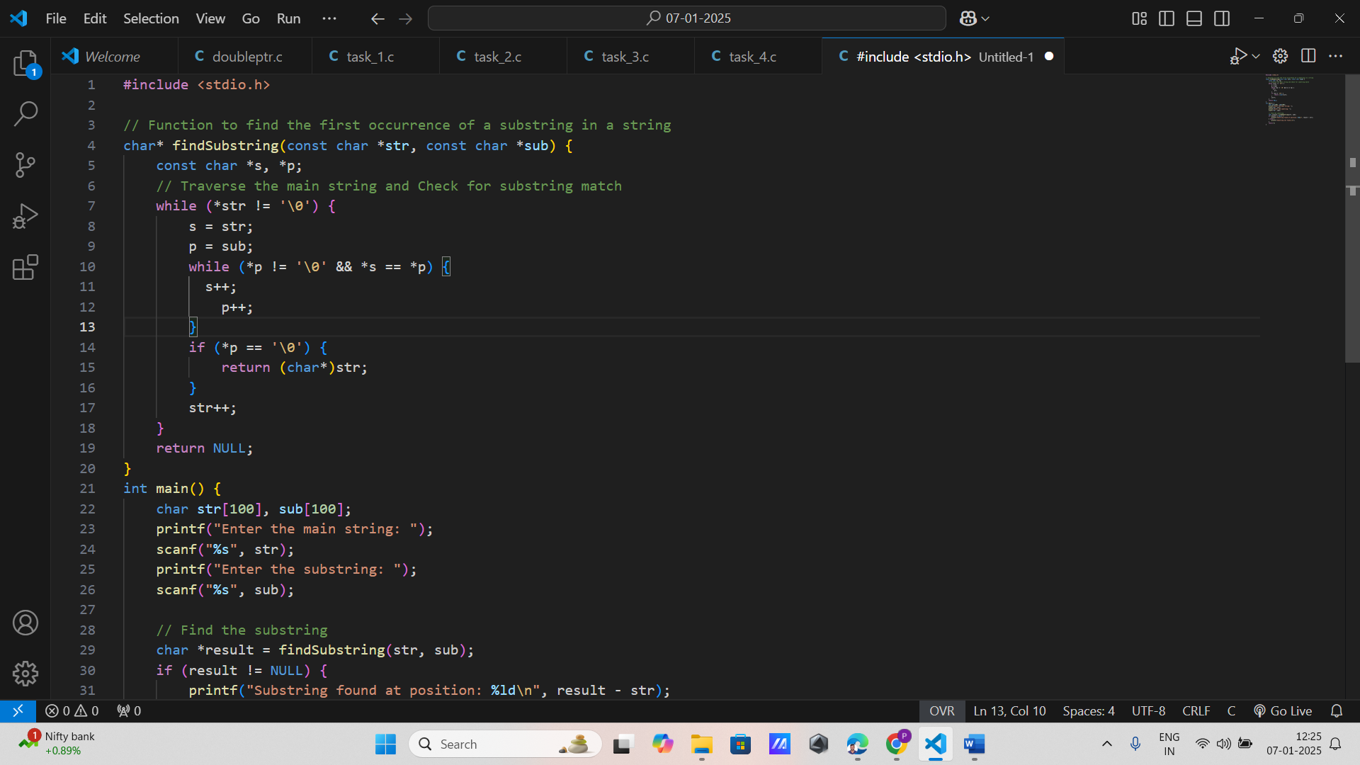

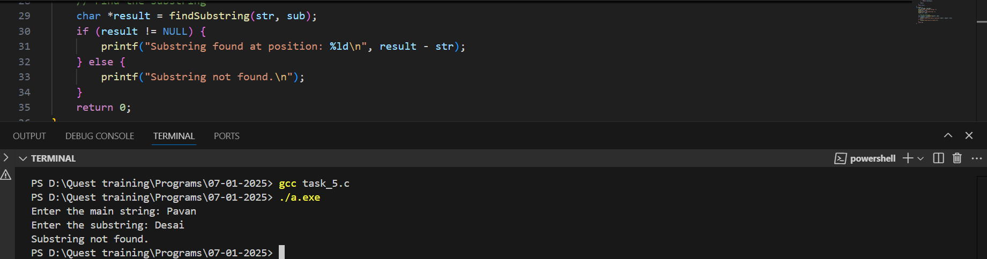

**6. Replace Character in String**

Write a function void replaceChar(char *str, char oldChar, char newChar) that replaces all occurrences of oldChar with newChar in the given string.

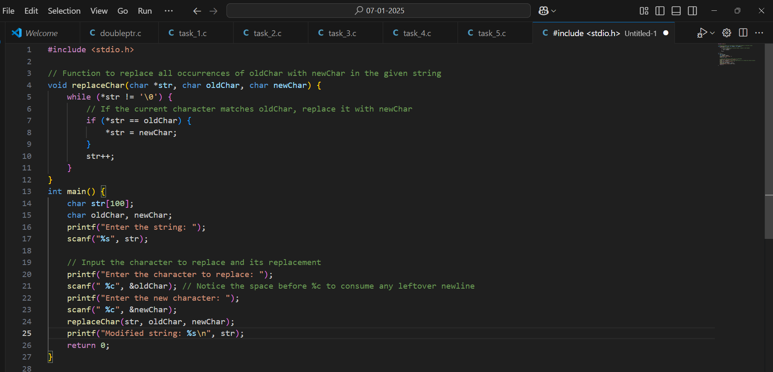

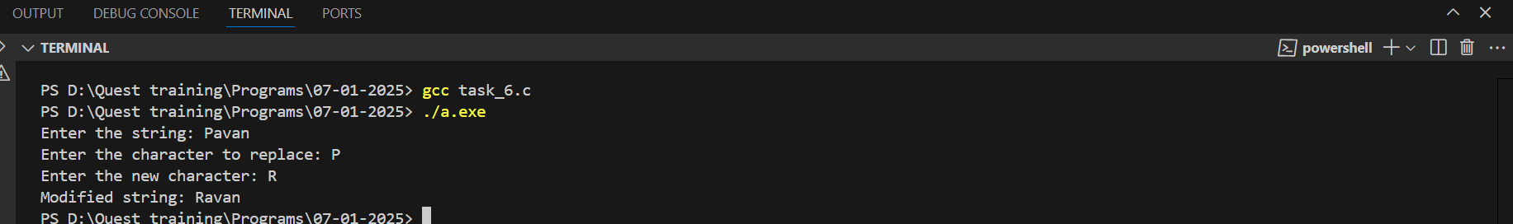

**7. Copy String**

Create a function void copyString(char *dest, const char *src) that copies the content of the source string src to the destination string dest.

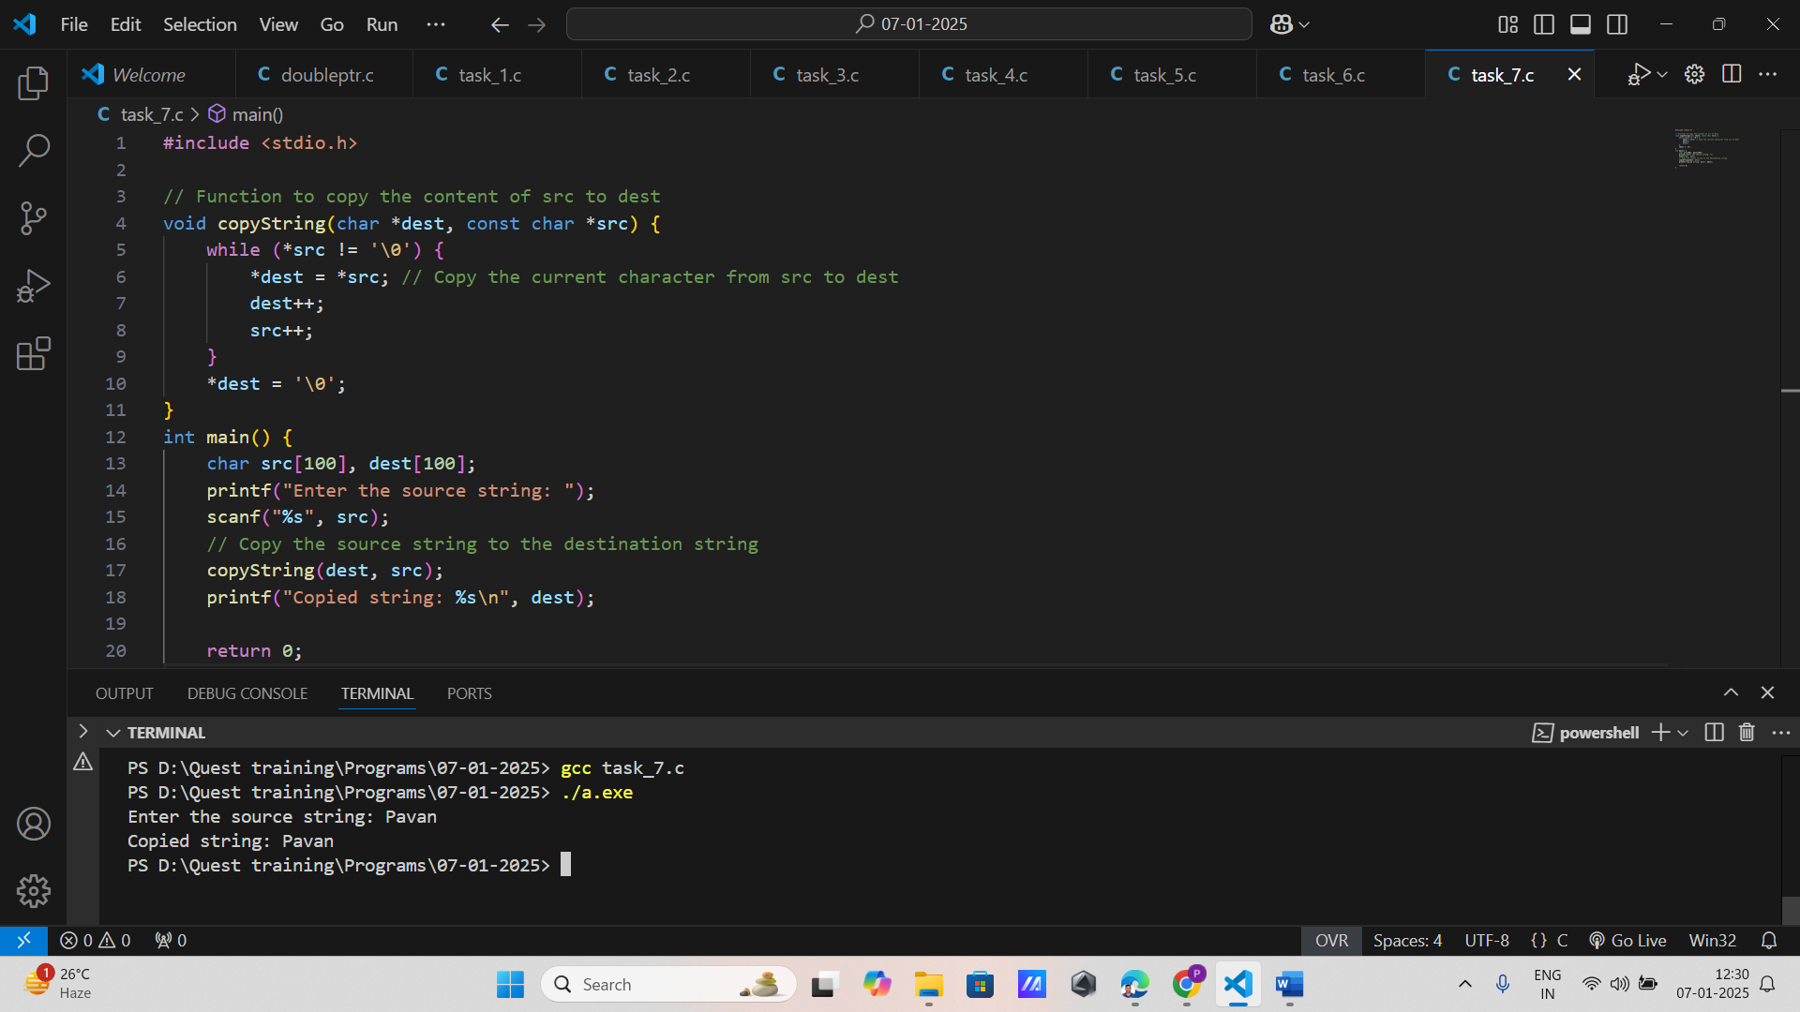

**8. Count Vowels in a String**

Implement int countVowels(const char *str) that counts and returns the number of vowels in a given string.

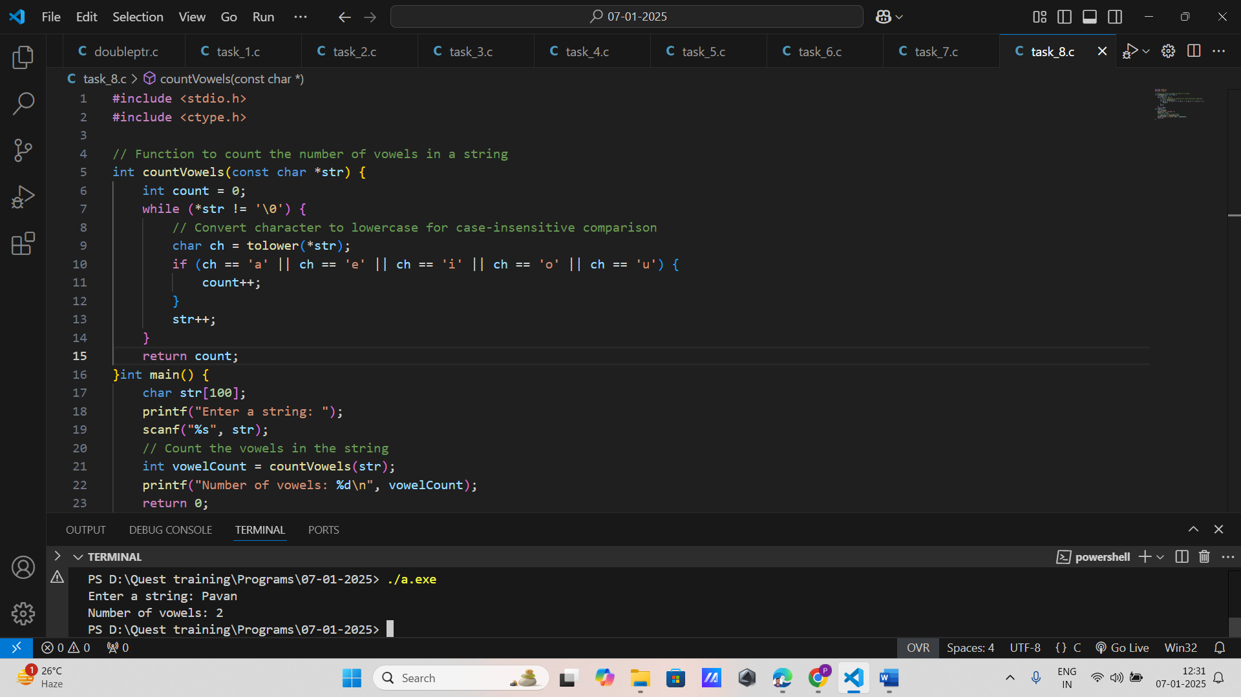

**9. Check Palindrome**

Write a function int isPalindrome(const char *str) that checks if a given string is a palindrome and returns 1 if true, otherwise 0.

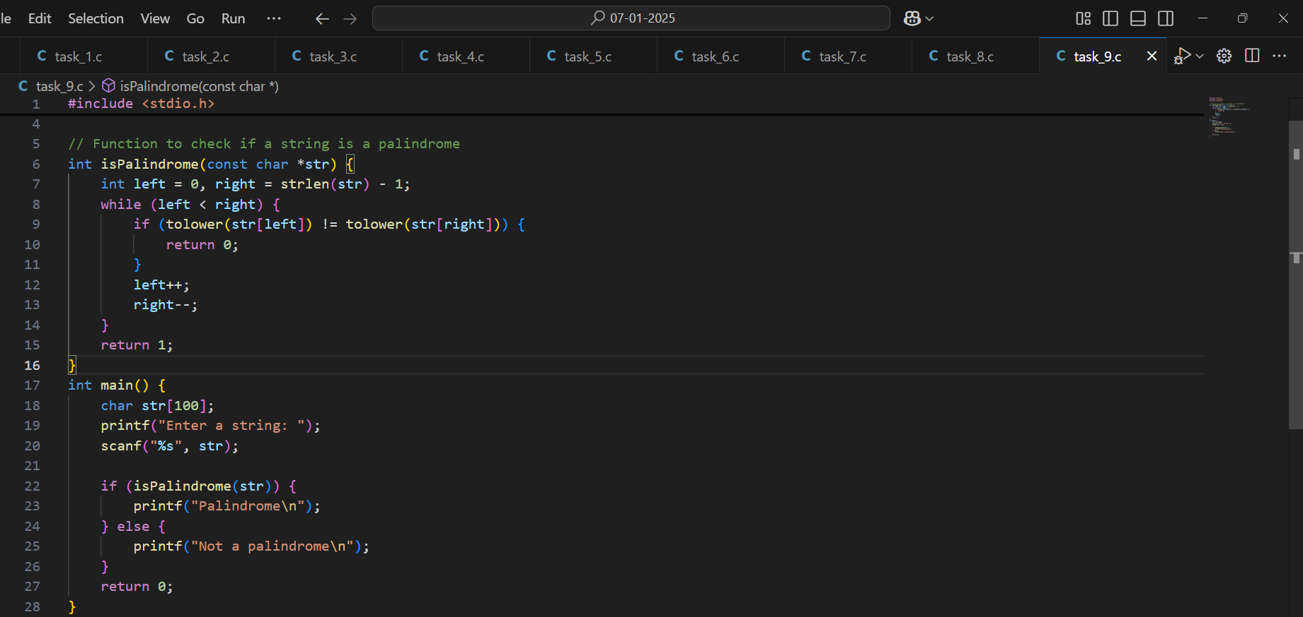

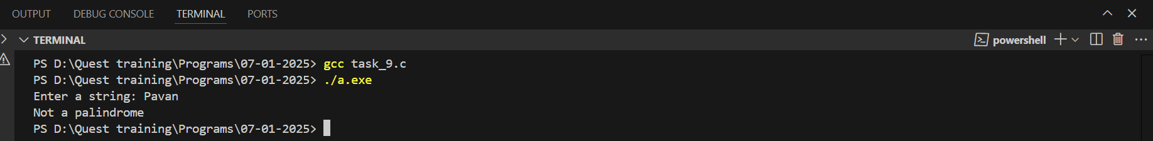

**10. Tokenize String**

Create a function void tokenizeString(char *str, const char *delim, void (*processToken)(const char *)) that tokenizes the string str using delimiters in delim, and for each token, calls processToken.

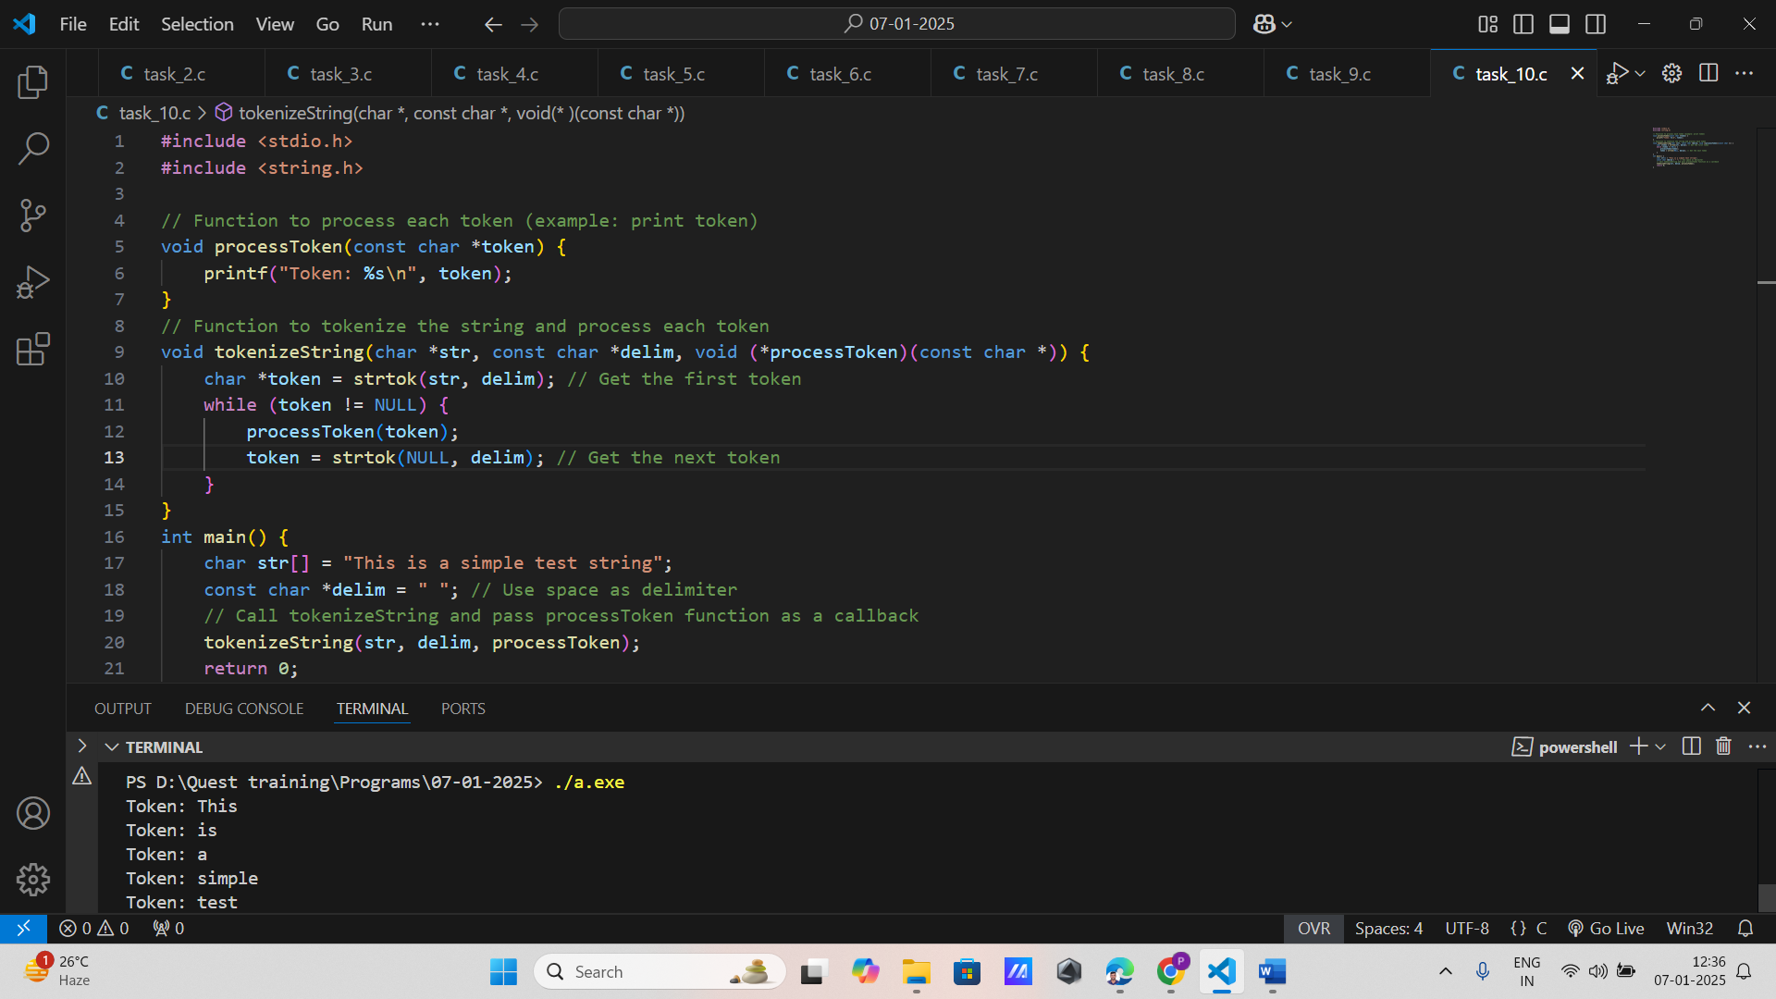

**Dynamic memory allocation**

**1. Allocate and Free Integer Array**

Write a program that dynamically allocates memory for an array of integers, fills it with values from 1 to n, and then frees the allocated memory.

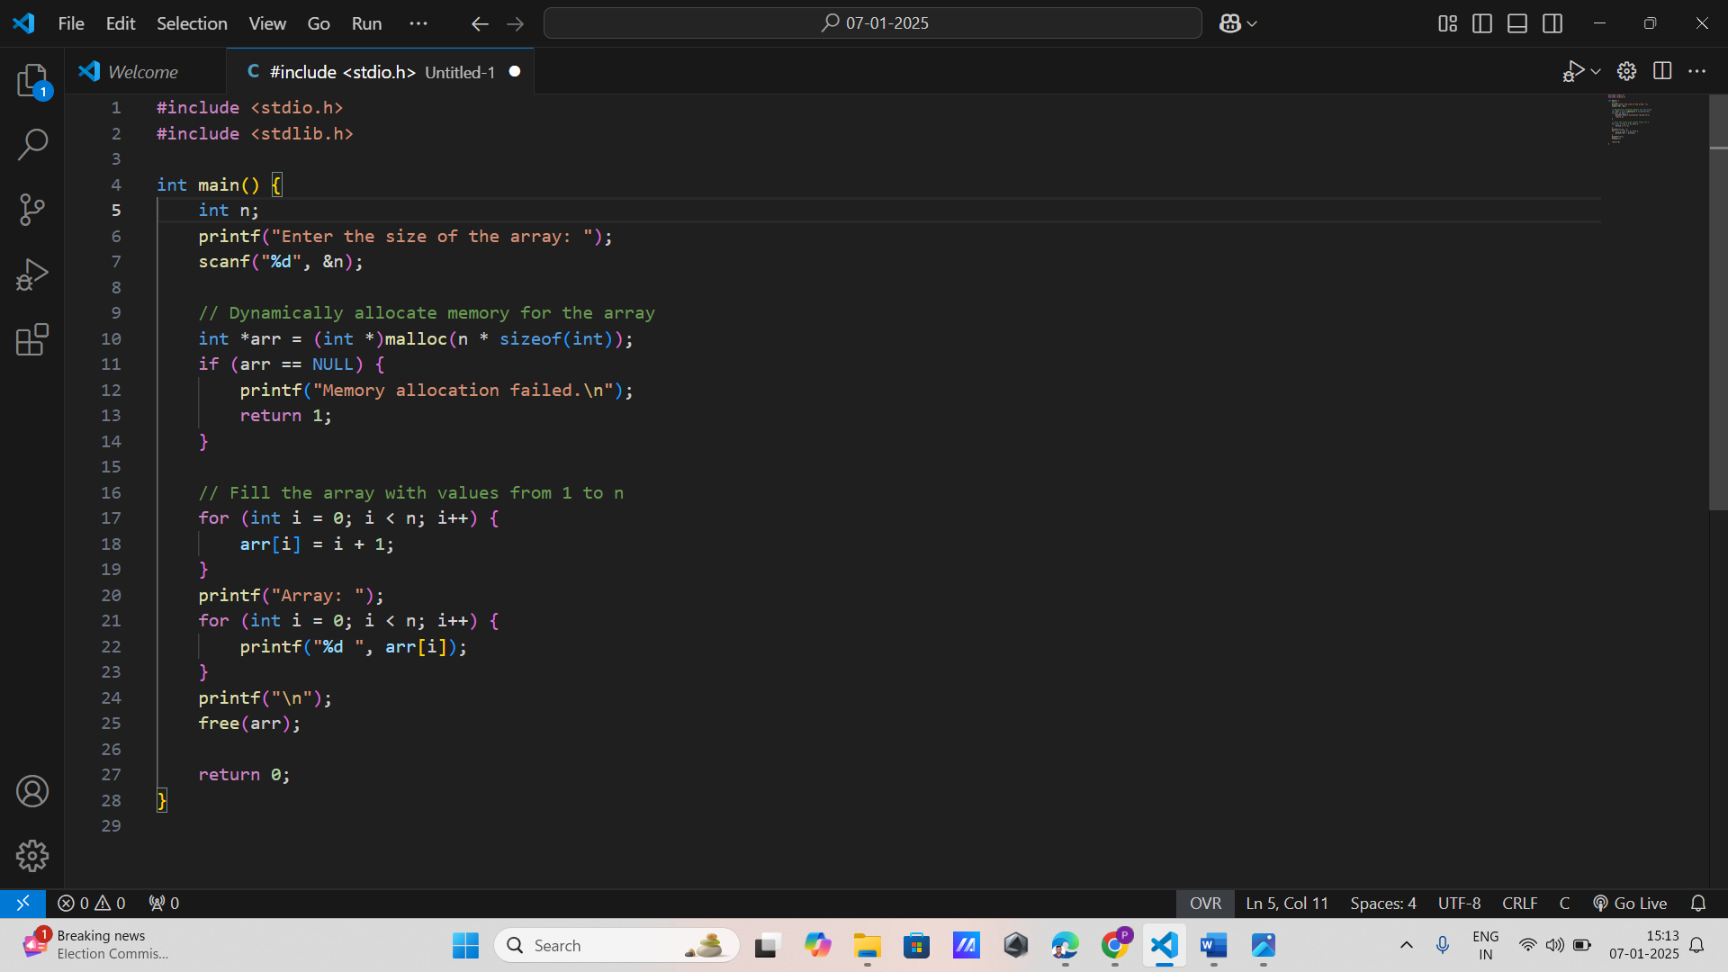

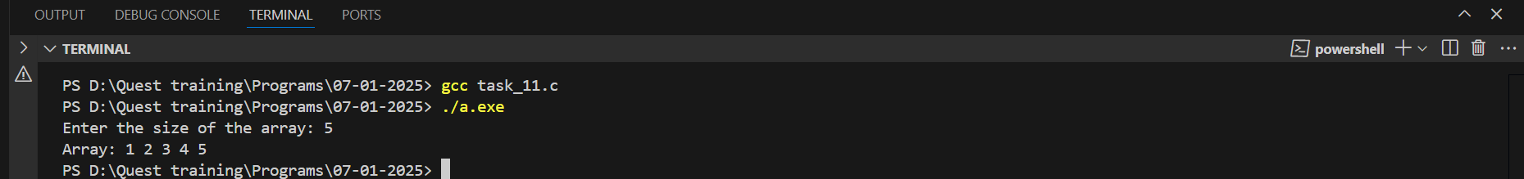

**2. Dynamic String Input**

Implement a function that dynamically allocates memory for a string, reads a string input from the user, and then prints the string. Free the memory after use.

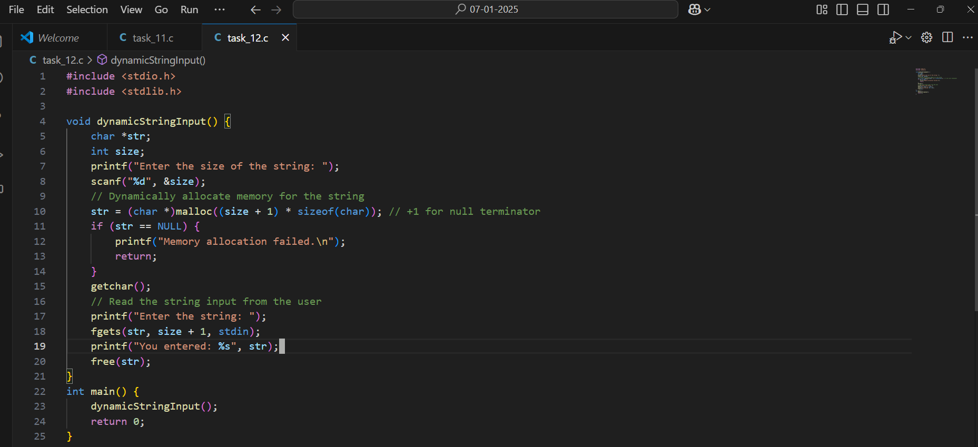

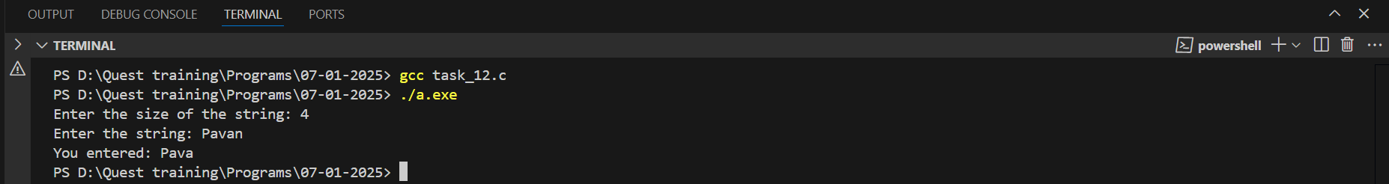

**3. Resize an Array**

Write a program that dynamically allocates memory for an array of n integers, fills it with values, resizes the array to 2n using realloc(), and fills the new elements with values.

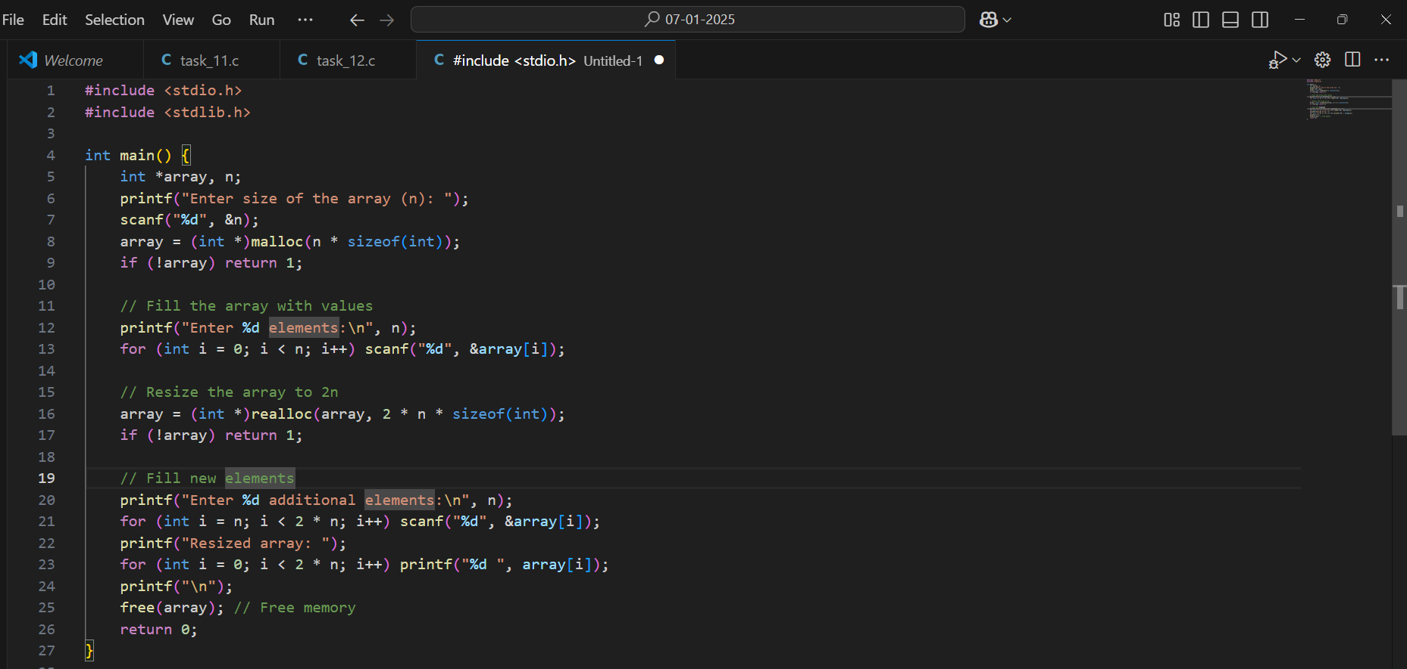

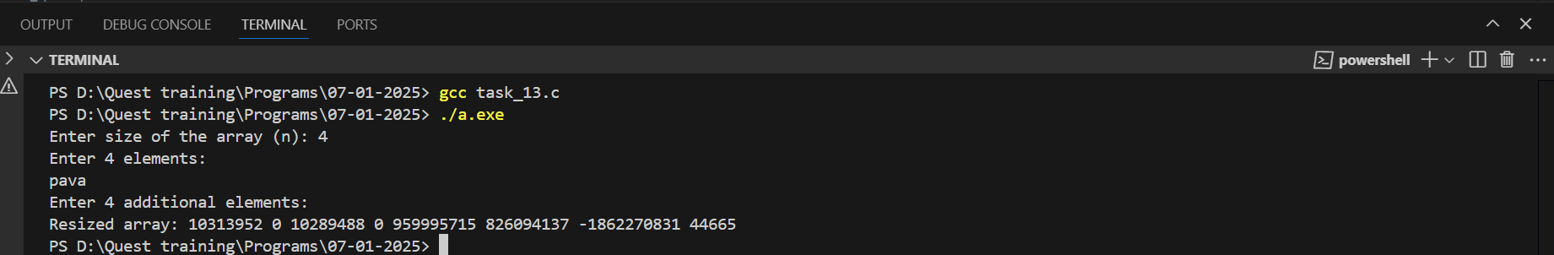

**4. Matrix Allocation**

Create a function that dynamically allocates memory for a 2D array (matrix) of size m x n, fills it with values, and then deallocates the memory.

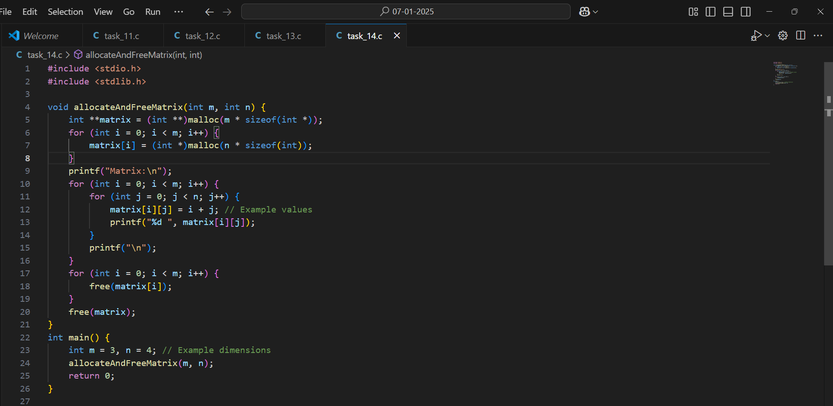

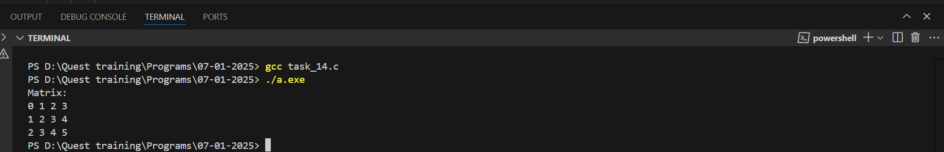

**5. String Concatenation with Dynamic Memory**

Implement a function that takes two strings, dynamically allocates memory to concatenate them, and returns the new concatenated string. Ensure to free the memory after use.

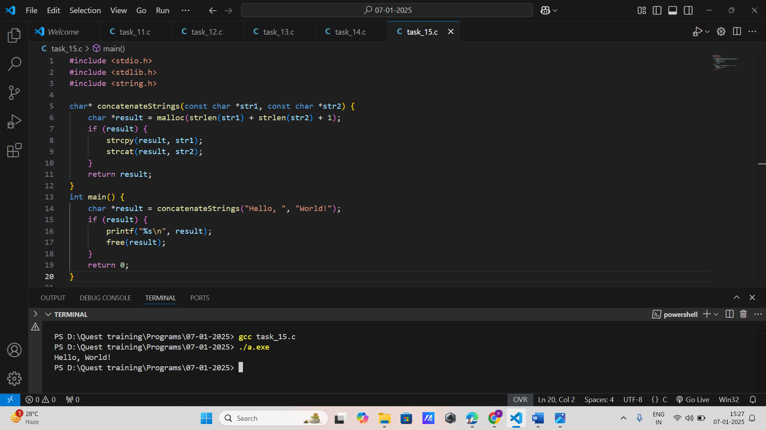

**6. Dynamic Memory for Structure**

Define a struct for a student with fields like name, age, and grade. Write a program that dynamically allocates memory for a student, fills in the details, and then frees the memory.

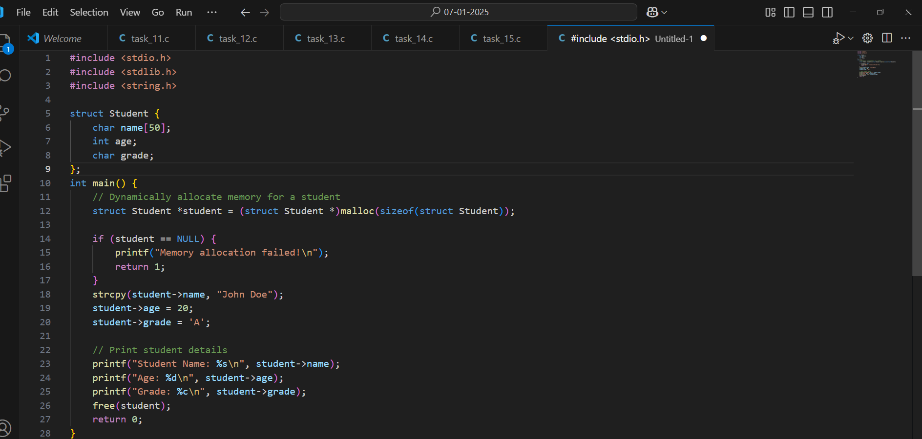

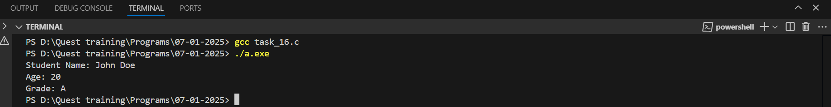

**8. Dynamic Array of Pointers**

Write a program that dynamically allocates memory for an array of pointers to integers, fills each integer with values, and then frees all the allocated memory.

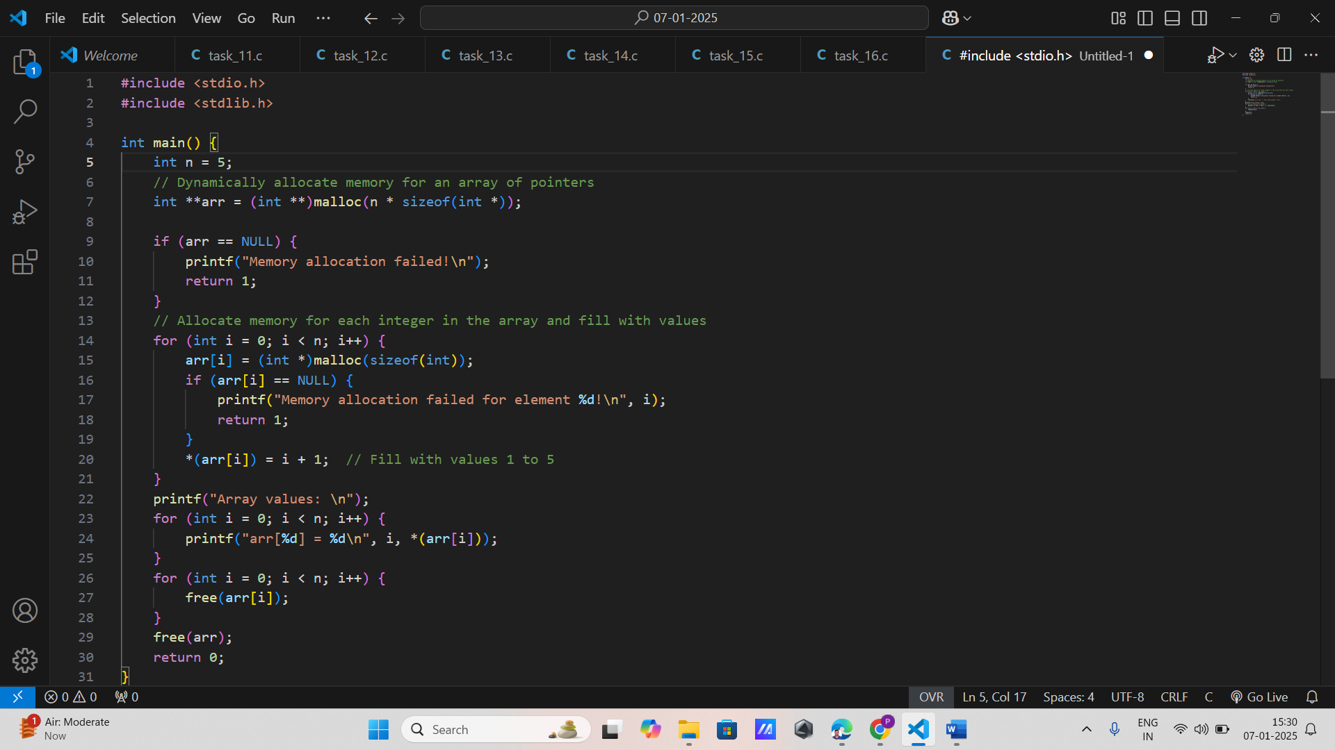

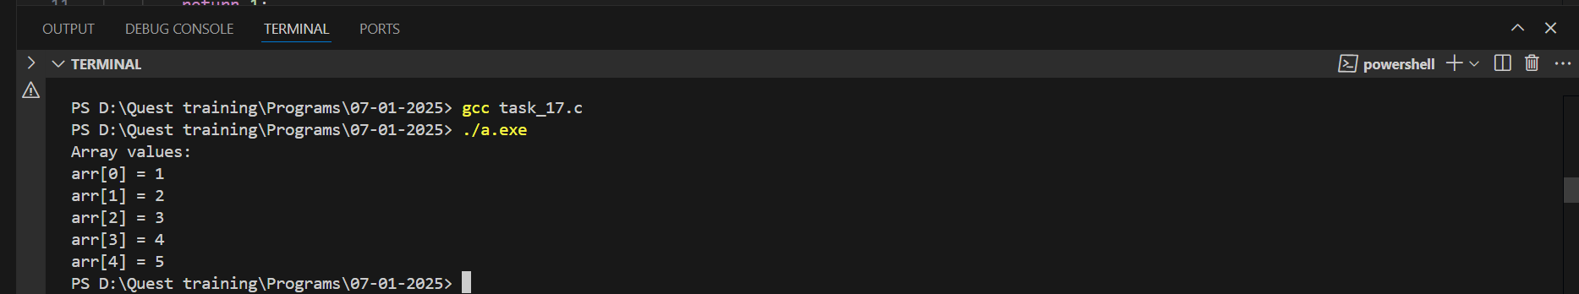

**9. Dynamic Memory for Multidimensional Arrays**

Create a program that dynamically allocates memory for a 3D array of integers, fills it with values, and deallocates the memory.

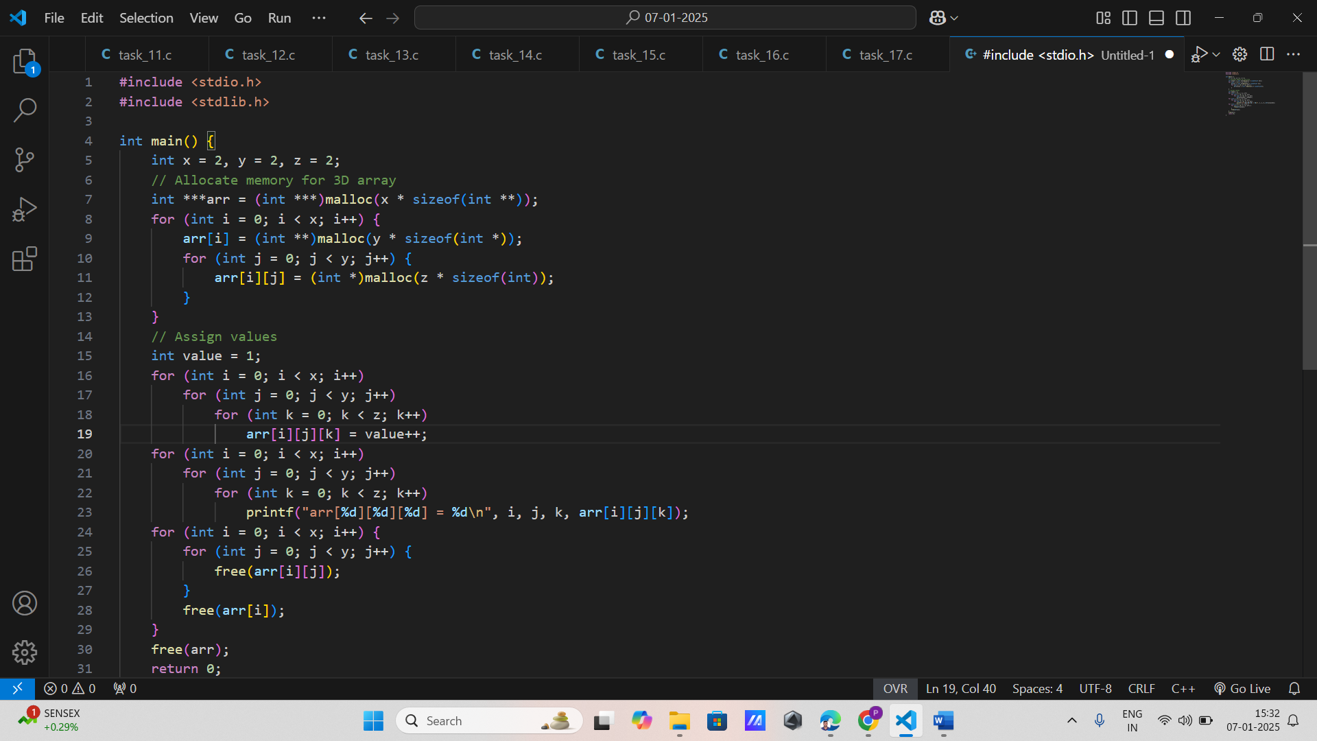

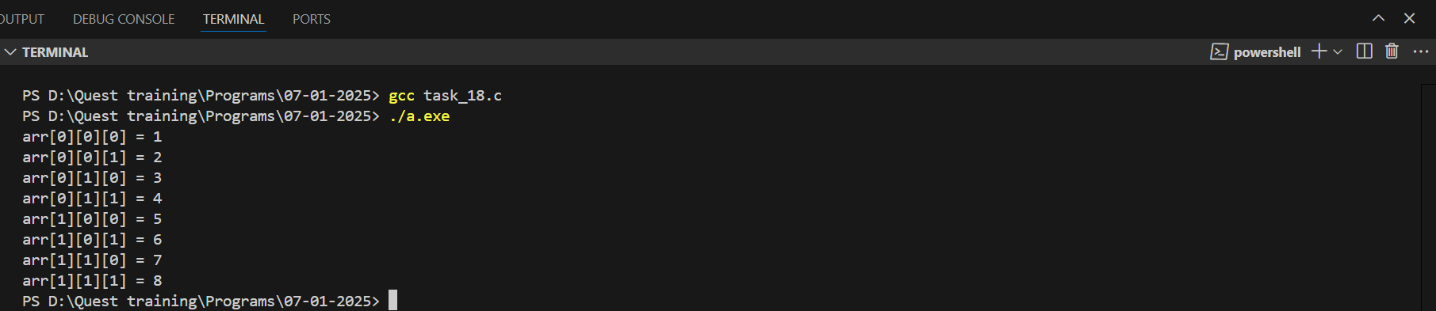

**Double Pointers**

**1. Swap Two Numbers Using Double Pointers**

Write a function void swap(int **a, int **b) that swaps the values of two integer pointers using double pointers.

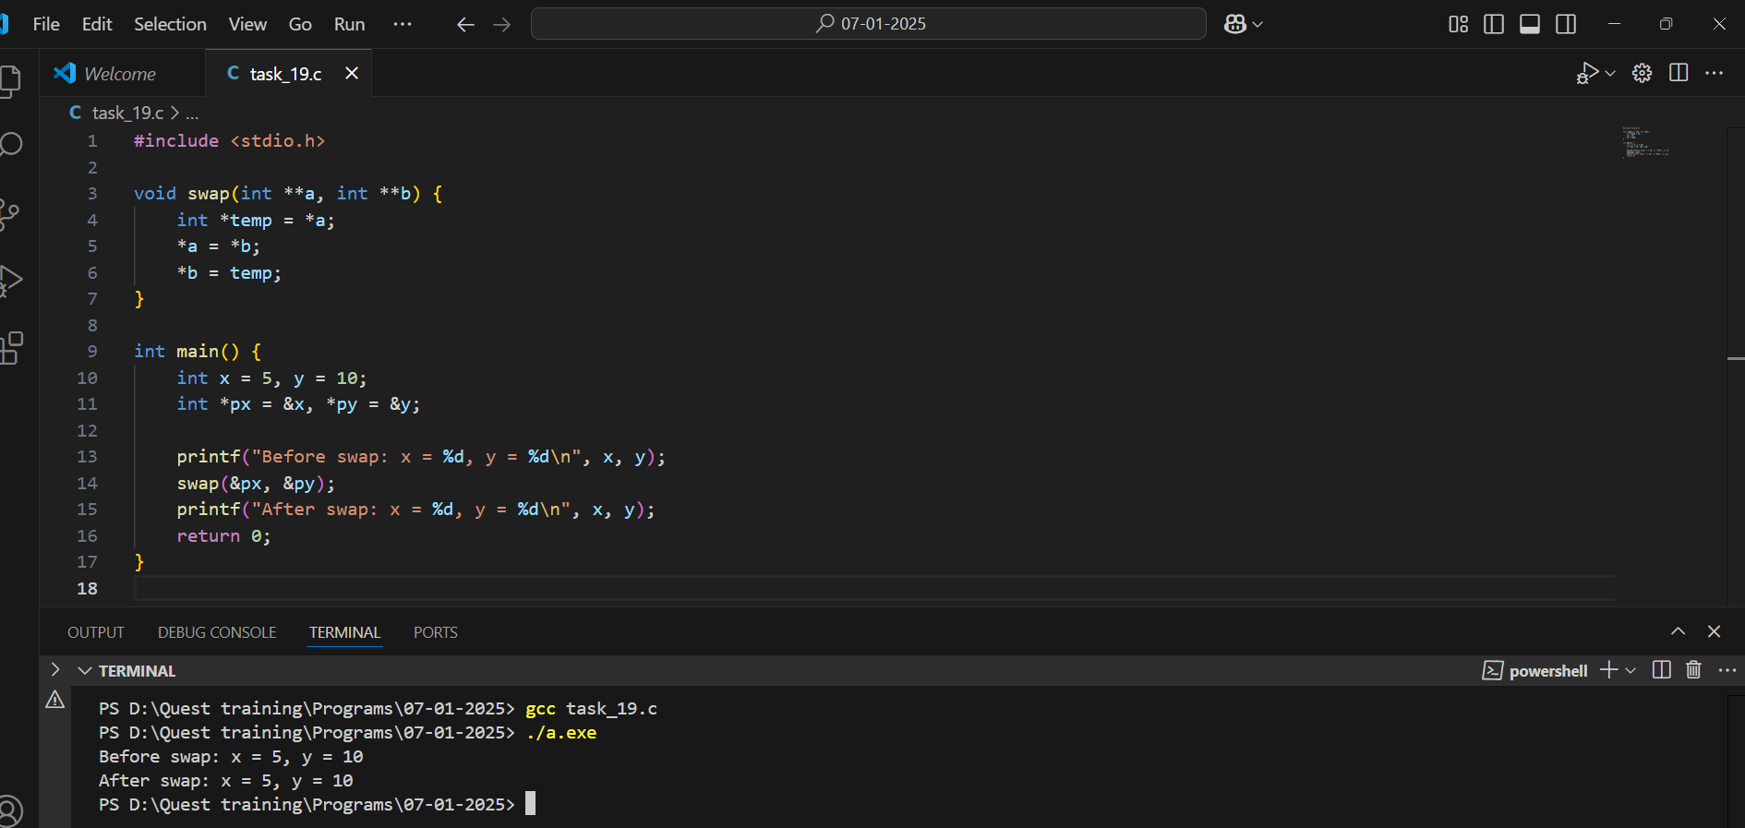

**2. Dynamic Memory Allocation Using Double Pointer**

Implement a function void allocateArray(int **arr, int size) that dynamically allocates memory for an array of integers using a double pointer.

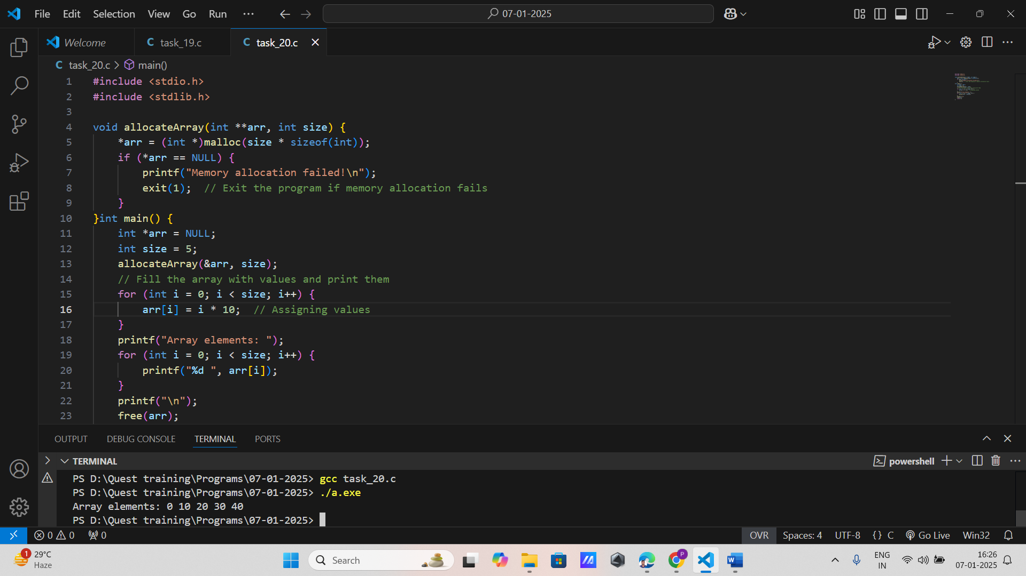

**3. Modify a String Using Double Pointer**

Write a function void modifyString(char **str) that takes a double pointer to a string, dynamically allocates a new string, assigns it to the pointer, and modifies the original string.

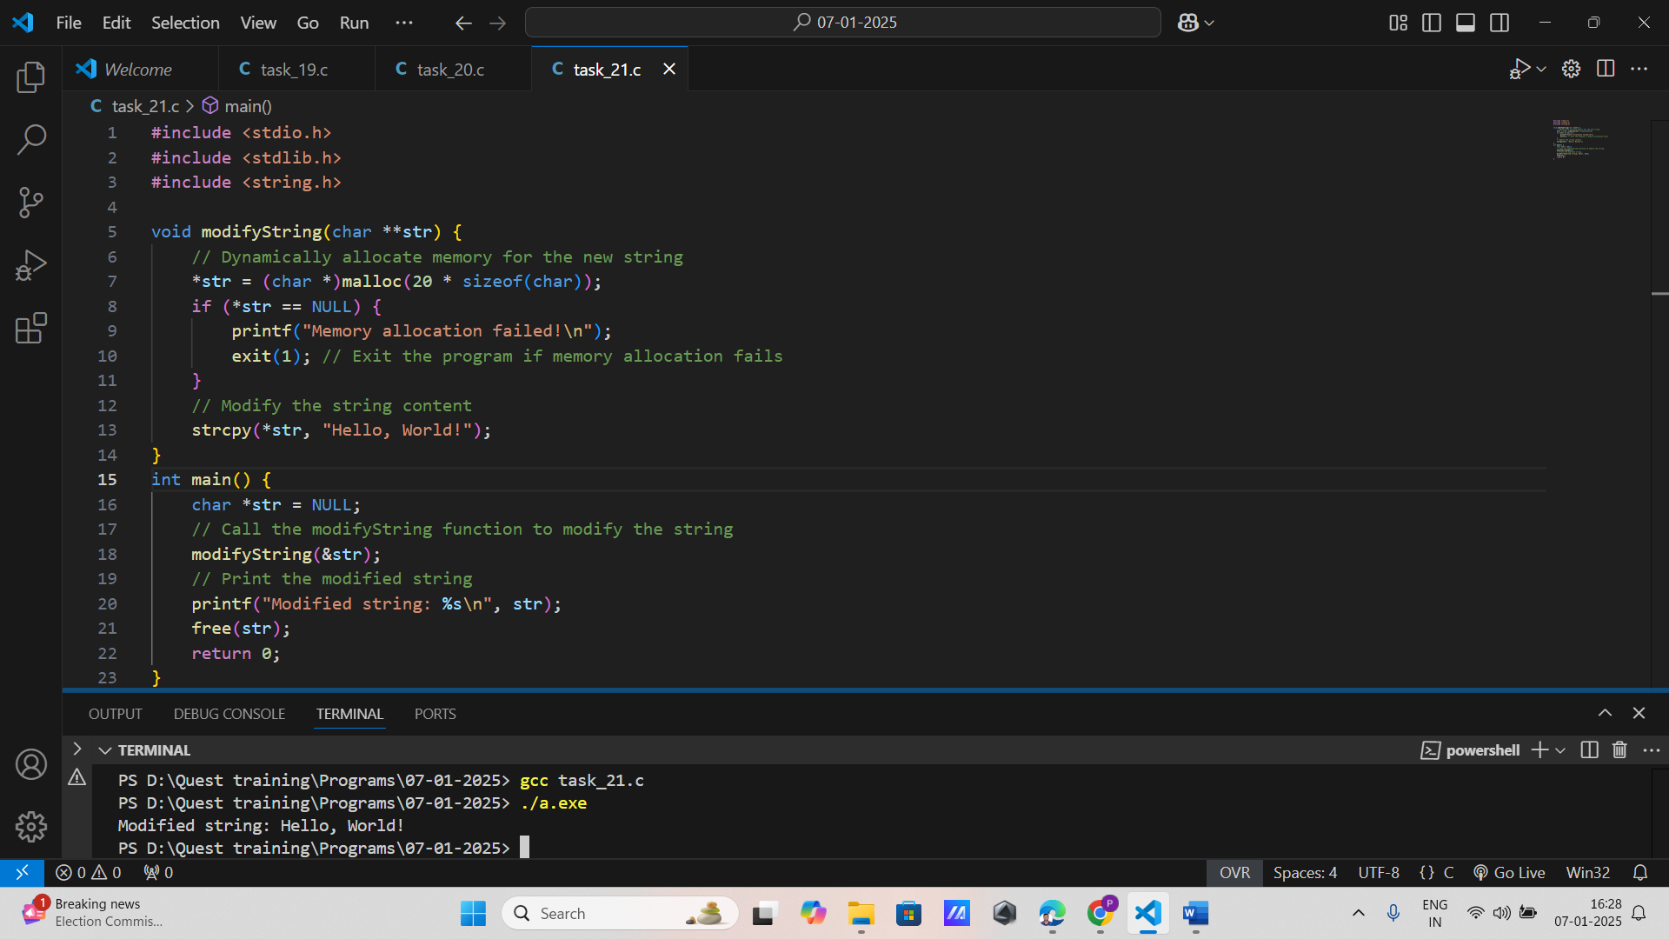

**4. Pointer to Pointer Example**

Create a simple program that demonstrates how to use a pointer to a pointer to access and modify the value of an integer.

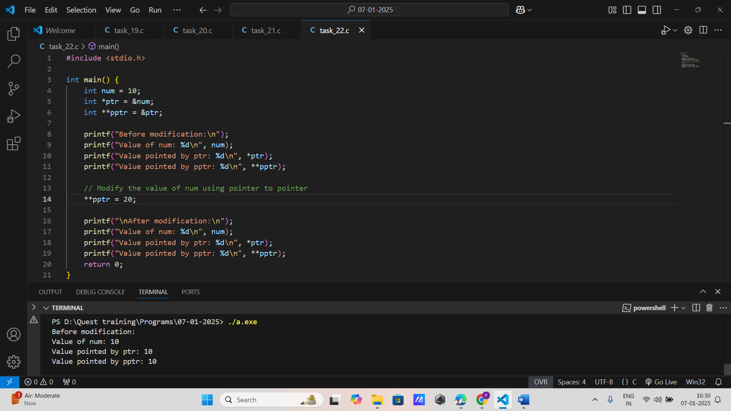

**5. 2D Array Using Double Pointer**

Write a function int** create2DArray(int rows, int cols) that dynamically allocates memory for a 2D array of integers using a double pointer and returns the pointer to the array.

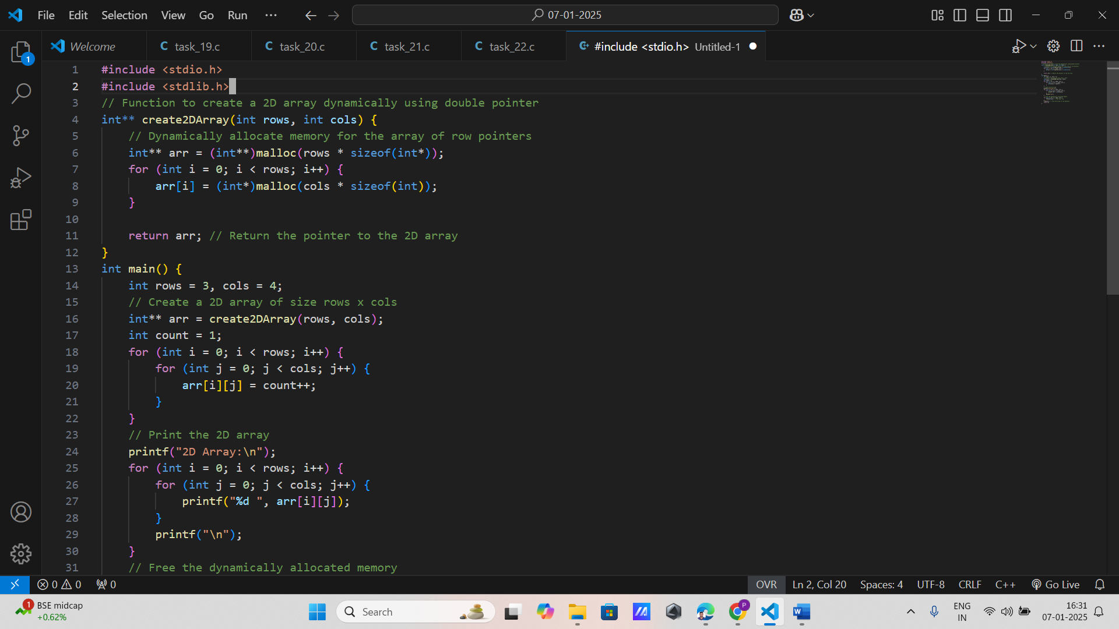

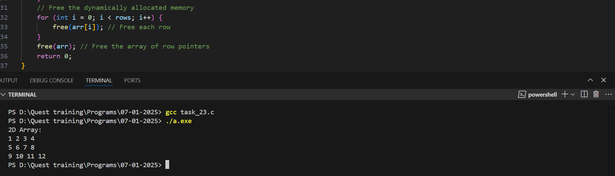

**6. Freeing 2D Array Using Double Pointer**

Implement a function void free2DArray(int **arr, int rows) that deallocates the memory allocated for a 2D array using a double pointer.

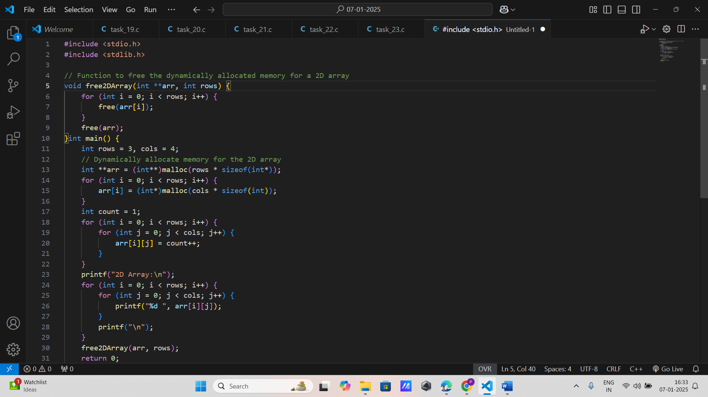

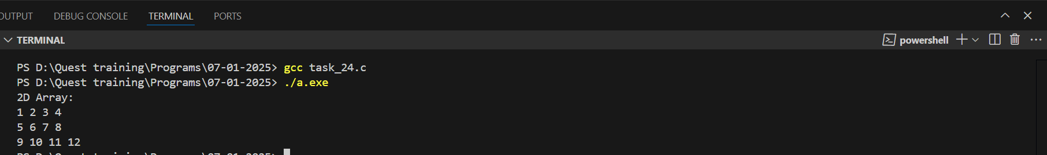

**7. Pass a Double Pointer to a Function**

Write a function void setPointer(int **ptr) that sets the pointer passed to it to point to a dynamically allocated integer.

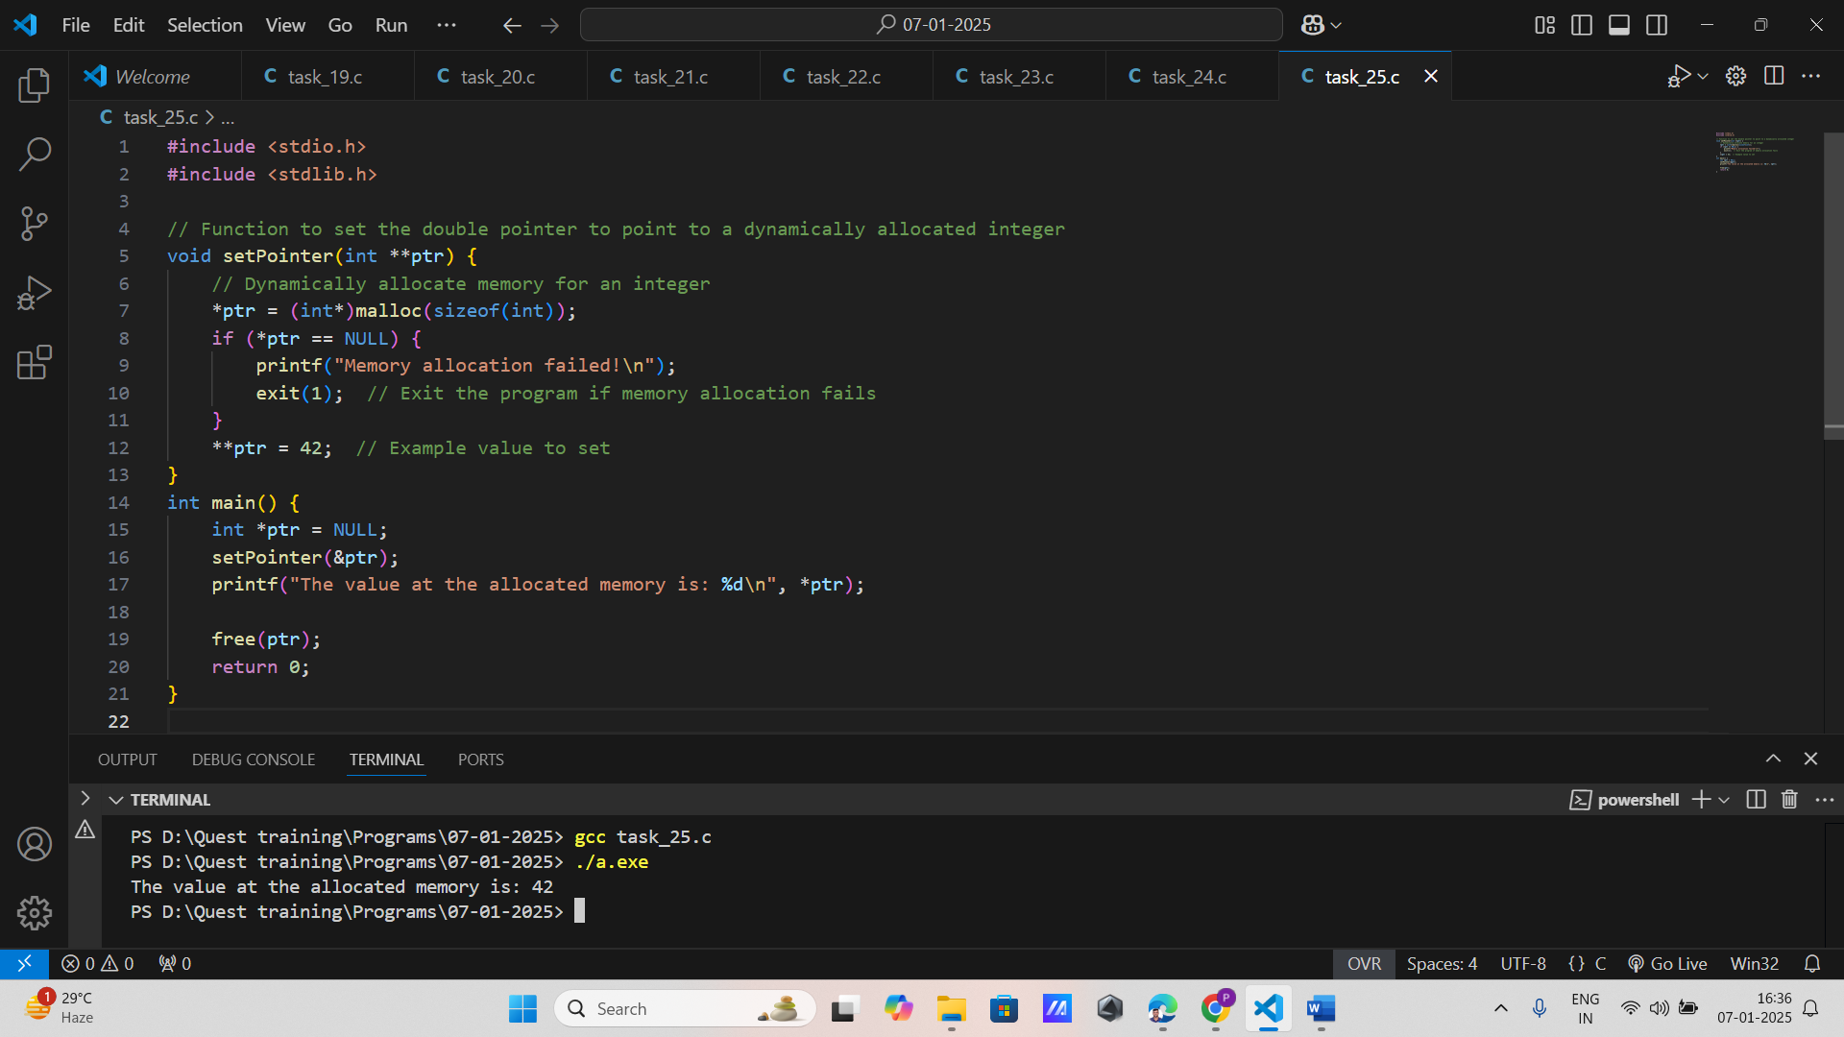

**8. Dynamic Array of Strings**

Create a function void allocateStringArray(char ***arr, int n) that dynamically allocates memory for an array of n strings using a double pointer.

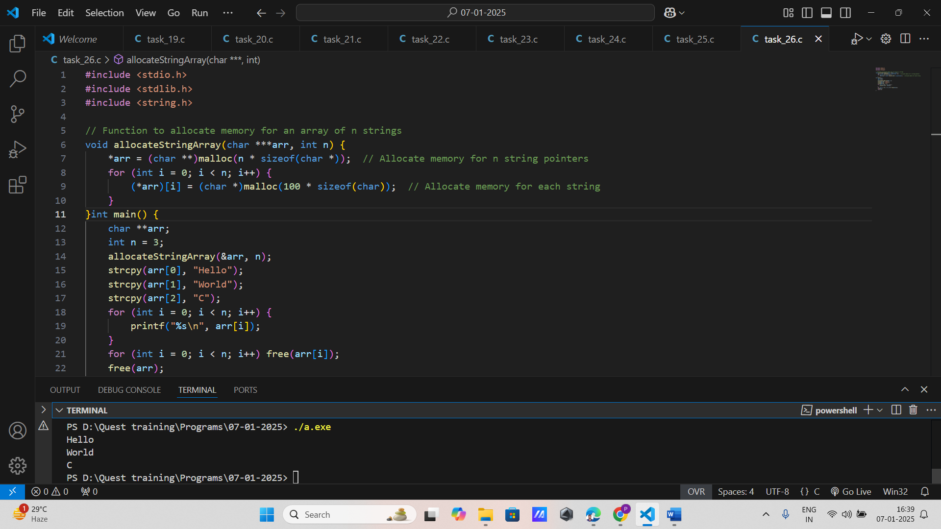

**9. String Array Manipulation Using Double Pointer**

Implement a function void modifyStringArray(char **arr, int n) that modifies each string in an array of strings using a double pointer.

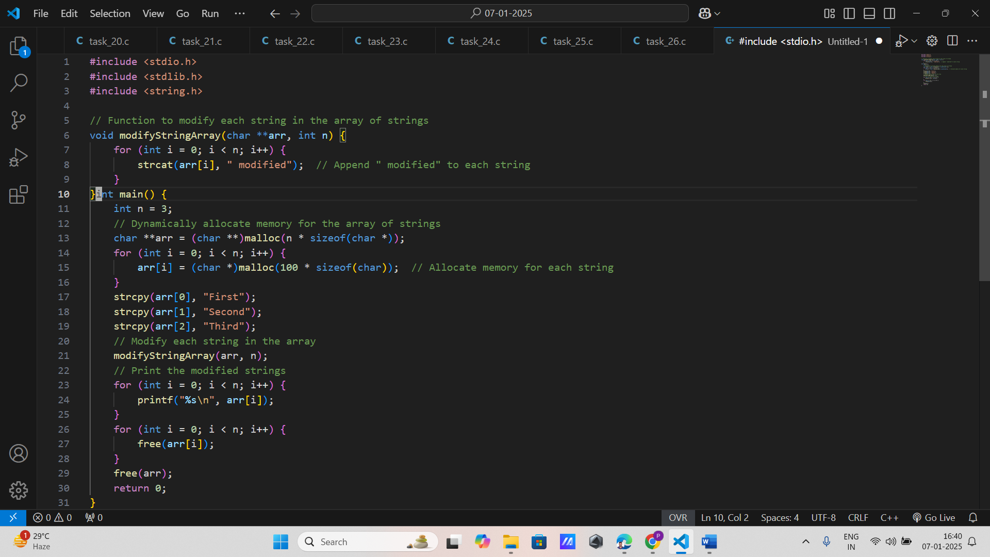

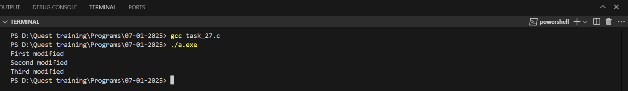

**Function Pointers**

**1. Basic Function Pointer Declaration**

Write a program that declares a function pointer for a function int add(int, int) and uses it to call the function and print the result.

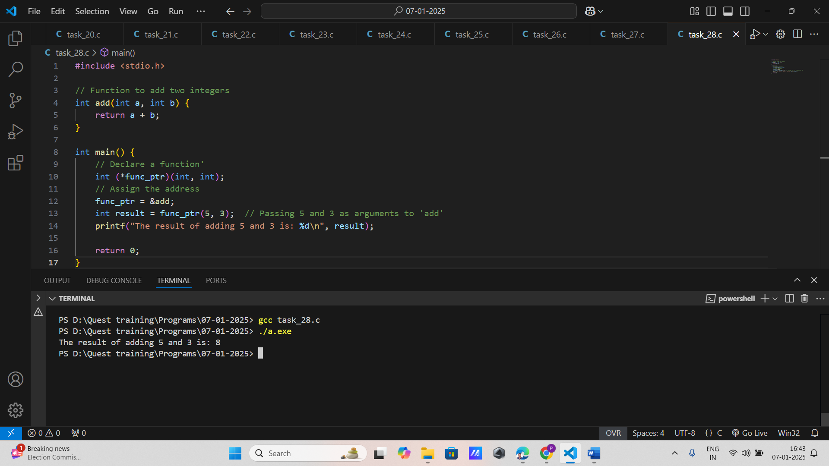

**2. Function Pointer as Argument**

Implement a function void performOperation(int (*operation)(int, int), int a, int b) that takes a function pointer as an argument and applies it to two integers, printing the result.

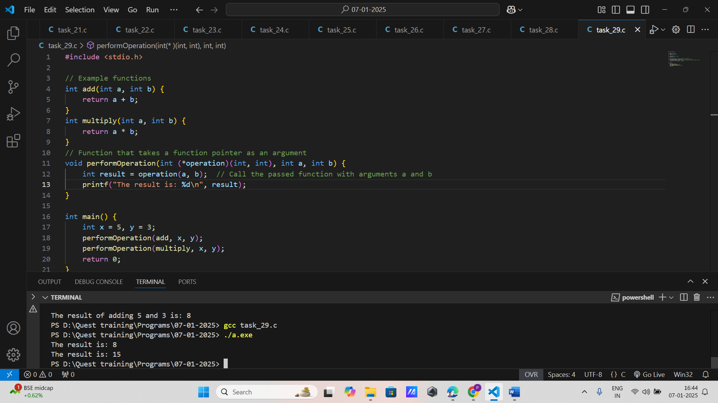

**3. Function Pointer Returning Pointer**

Write a program with a function int* max(int *a, int *b) that returns a pointer to the larger of two integers, and use a function pointer to call this function.

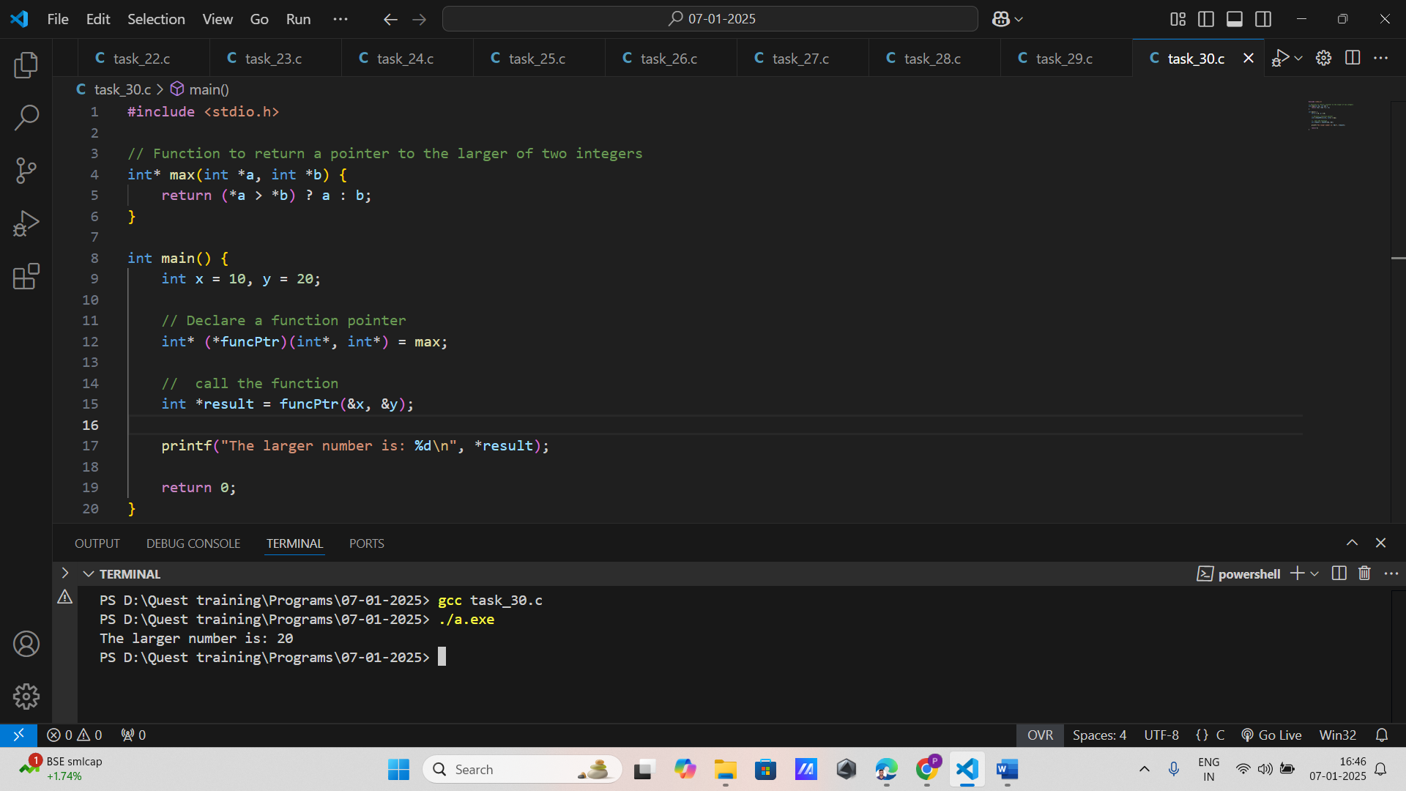

**4. Function Pointer with Different Functions**

Create a program that defines two functions int add(int, int) and int multiply(int, int) and uses a function pointer to dynamically switch between these functions based on user input.

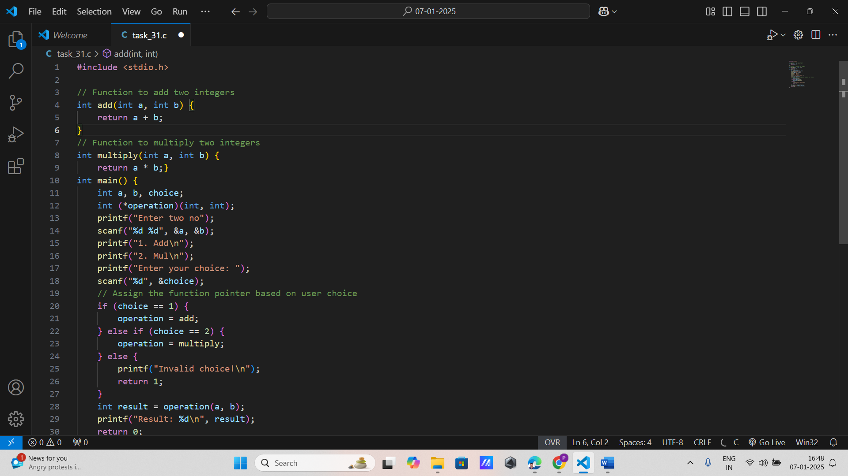

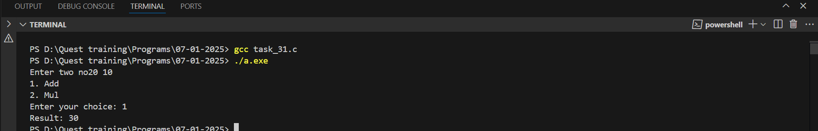

**5. Array of Function Pointers**

Implement a program that creates an array of function pointers for basic arithmetic operations (addition, subtraction, multiplication, division) and allows the user to select and execute one operation.

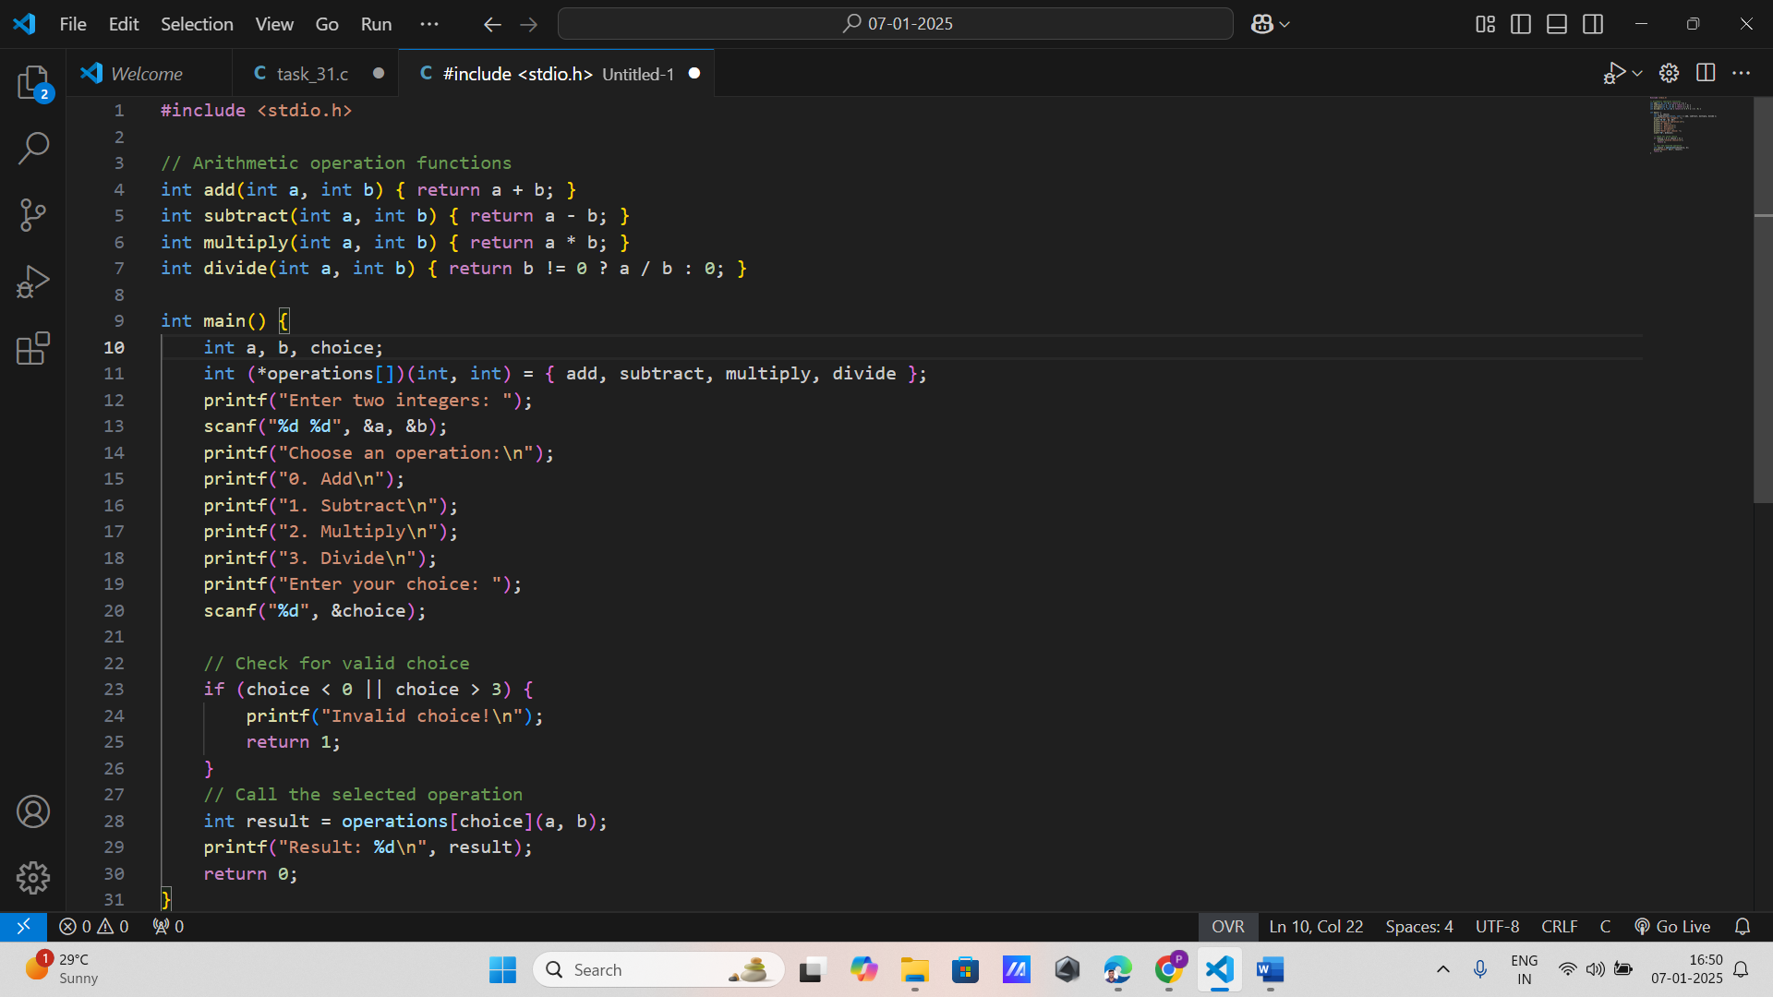

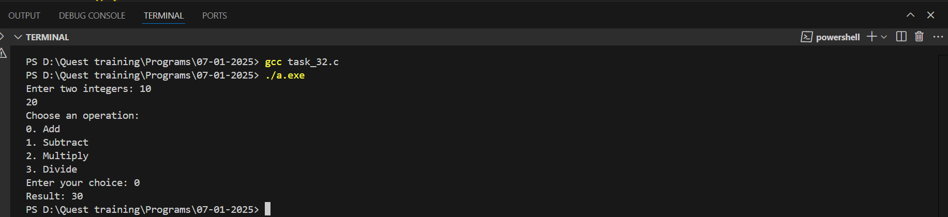

**6. Using Function Pointers for Sorting**

Write a function void sort(int *arr, int size, int (*compare)(int, int)) that uses a function pointer to compare elements, allowing for both ascending and descending order sorting.

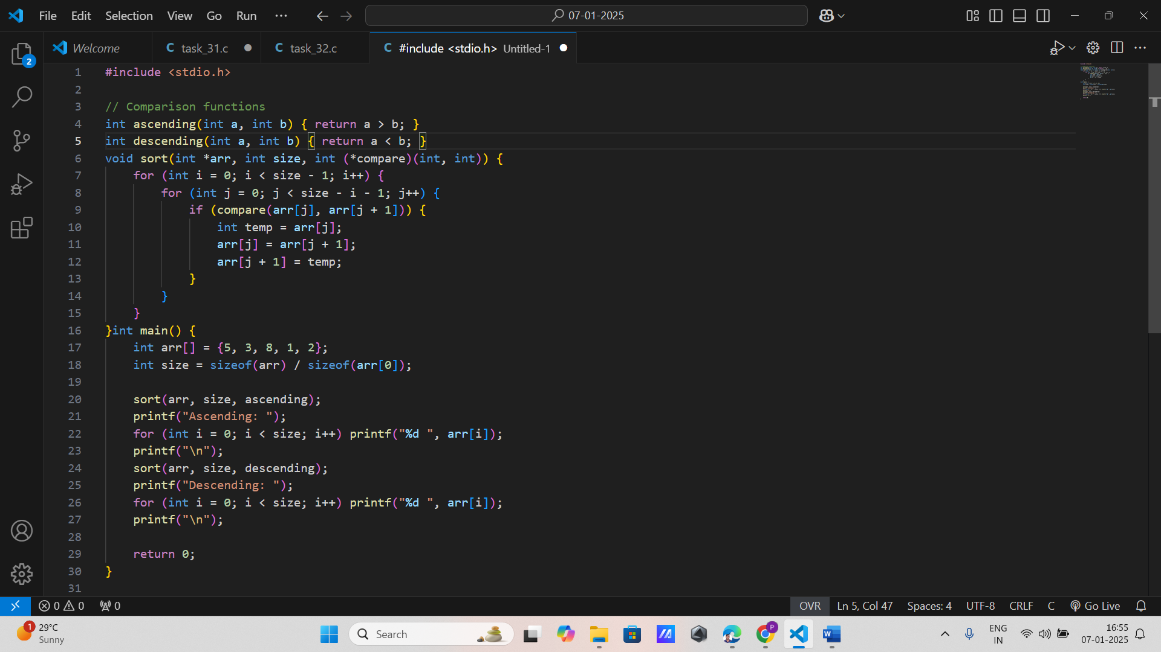

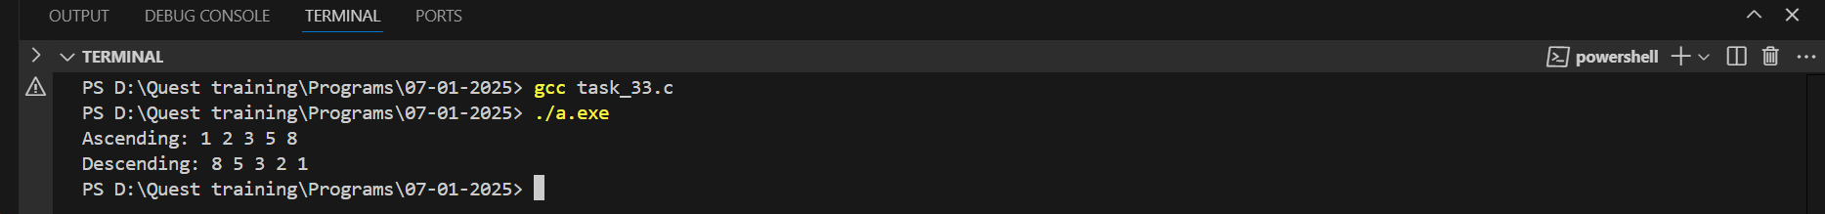

**7. Callback Function**

Create a program with a function void execute(int x, int (*callback)(int)) that applies a callback function to an integer and prints the result. Demonstrate with multiple callback functions (e.g., square, cube).

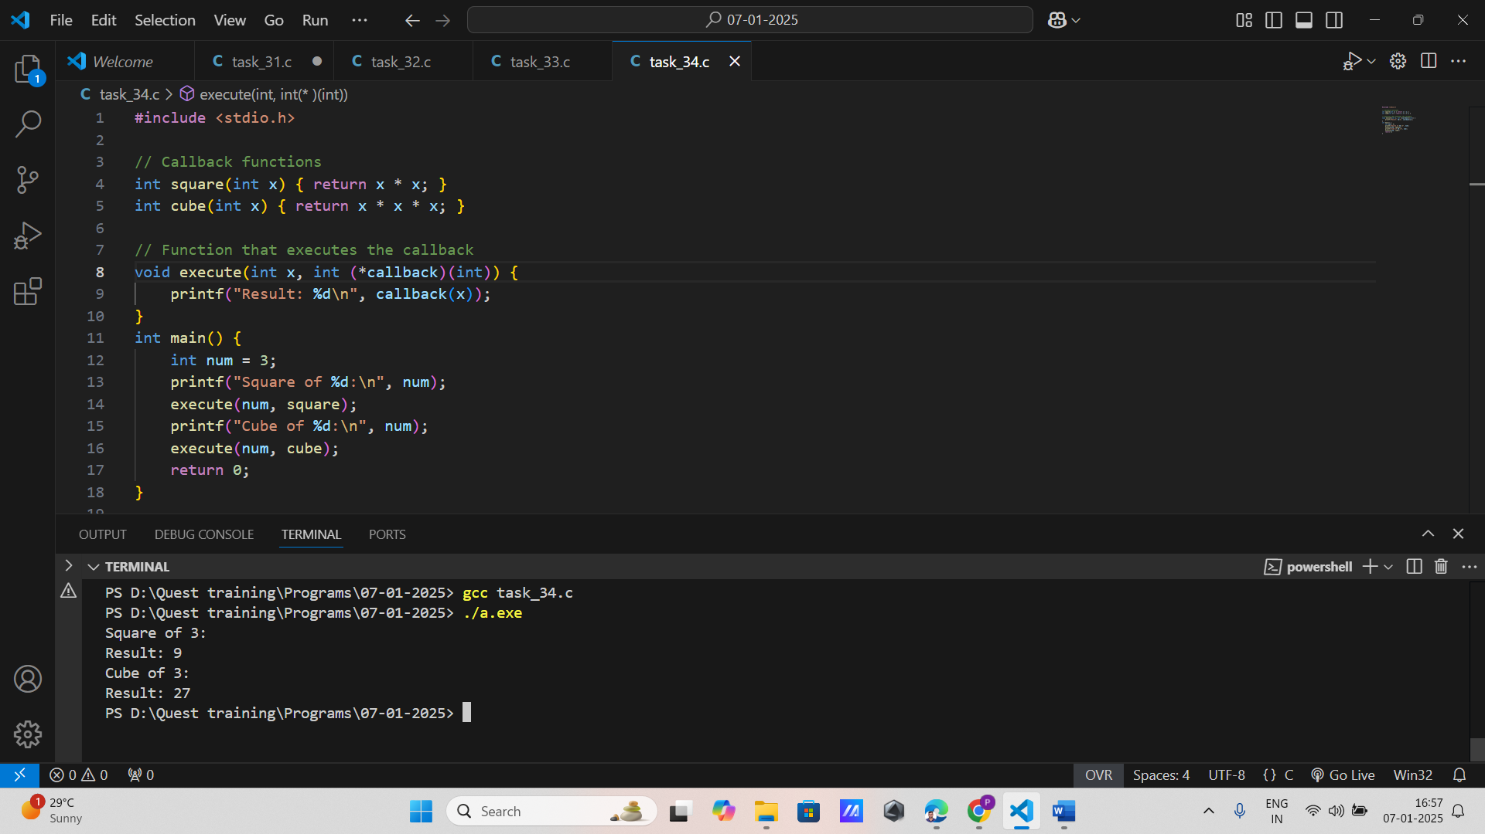

**8. Menu System Using Function Pointers**

Implement a simple menu system where each menu option corresponds to a different function, and a function pointer array is used to call the selected function based on user input.

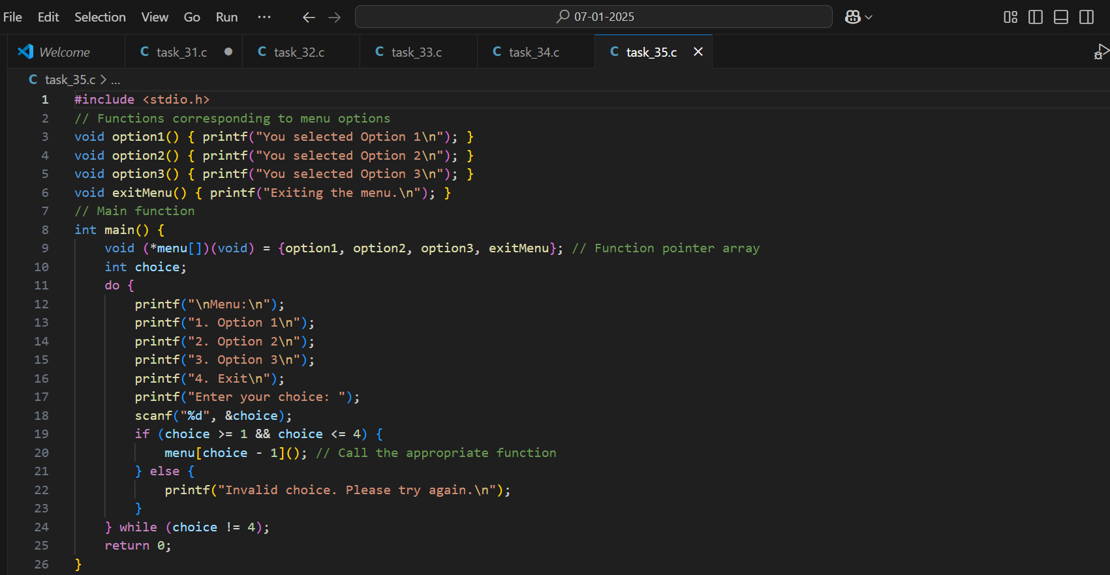

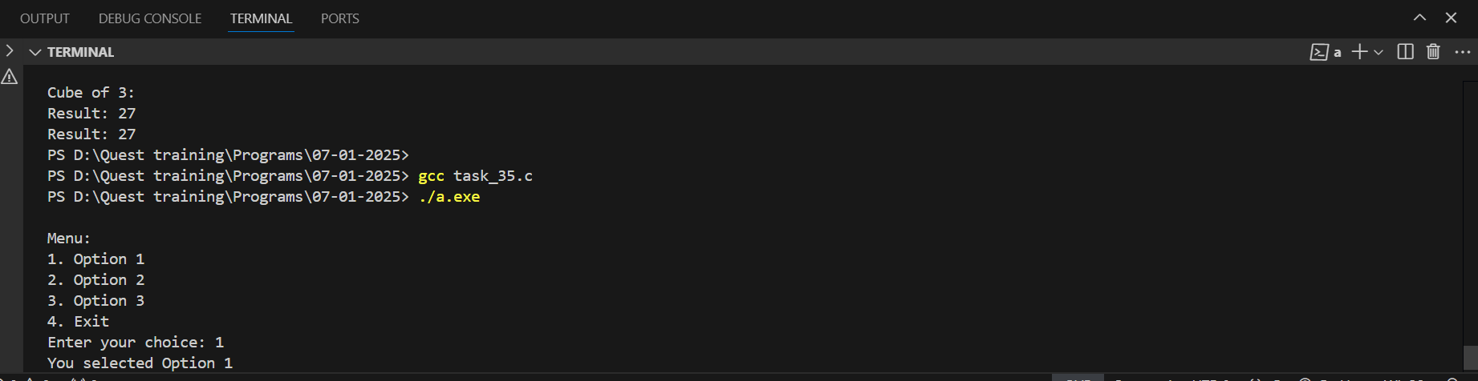

**9. Dynamic Function Selection**

Write a program where the user inputs an operation symbol (+, -, *, /) and the program uses a function pointer to call the corresponding function.

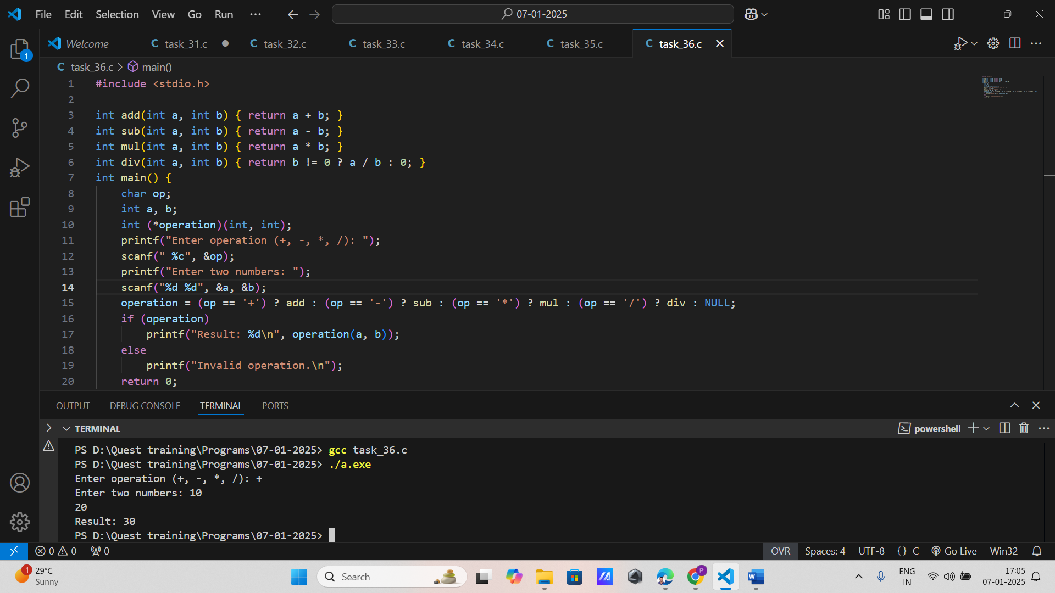

**10. State Machine with Function Pointers**

Design a simple state machine where each state is represented by a function, and transitions are handled using function pointers. For example, implement a traffic light system with states like Red, Green, and Yellow.

